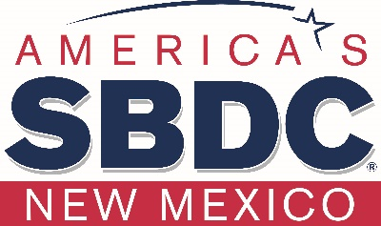
CY21 Program Year
January 1 – December 31, 2021

New Mexico Small Business Development Center (NMSBDC) Program Foundational Documents
- Statewide Business Plan Cycle
- Statewide Business Plan
- Measures
- Definitions

“These Foundational Documents are the focus of the NMSBDC CY21 Program Year; they are designed to move the program towards fulfilling our mission, vision and values. As a network working together your involvement is essential, necessary and appreciated in making our Business Plan a reality and adding value to our clients and stakeholders.” NMSBDC Lead Center Team
Instructions
Please keep this on your desk for quick reference.

