Plan July - September
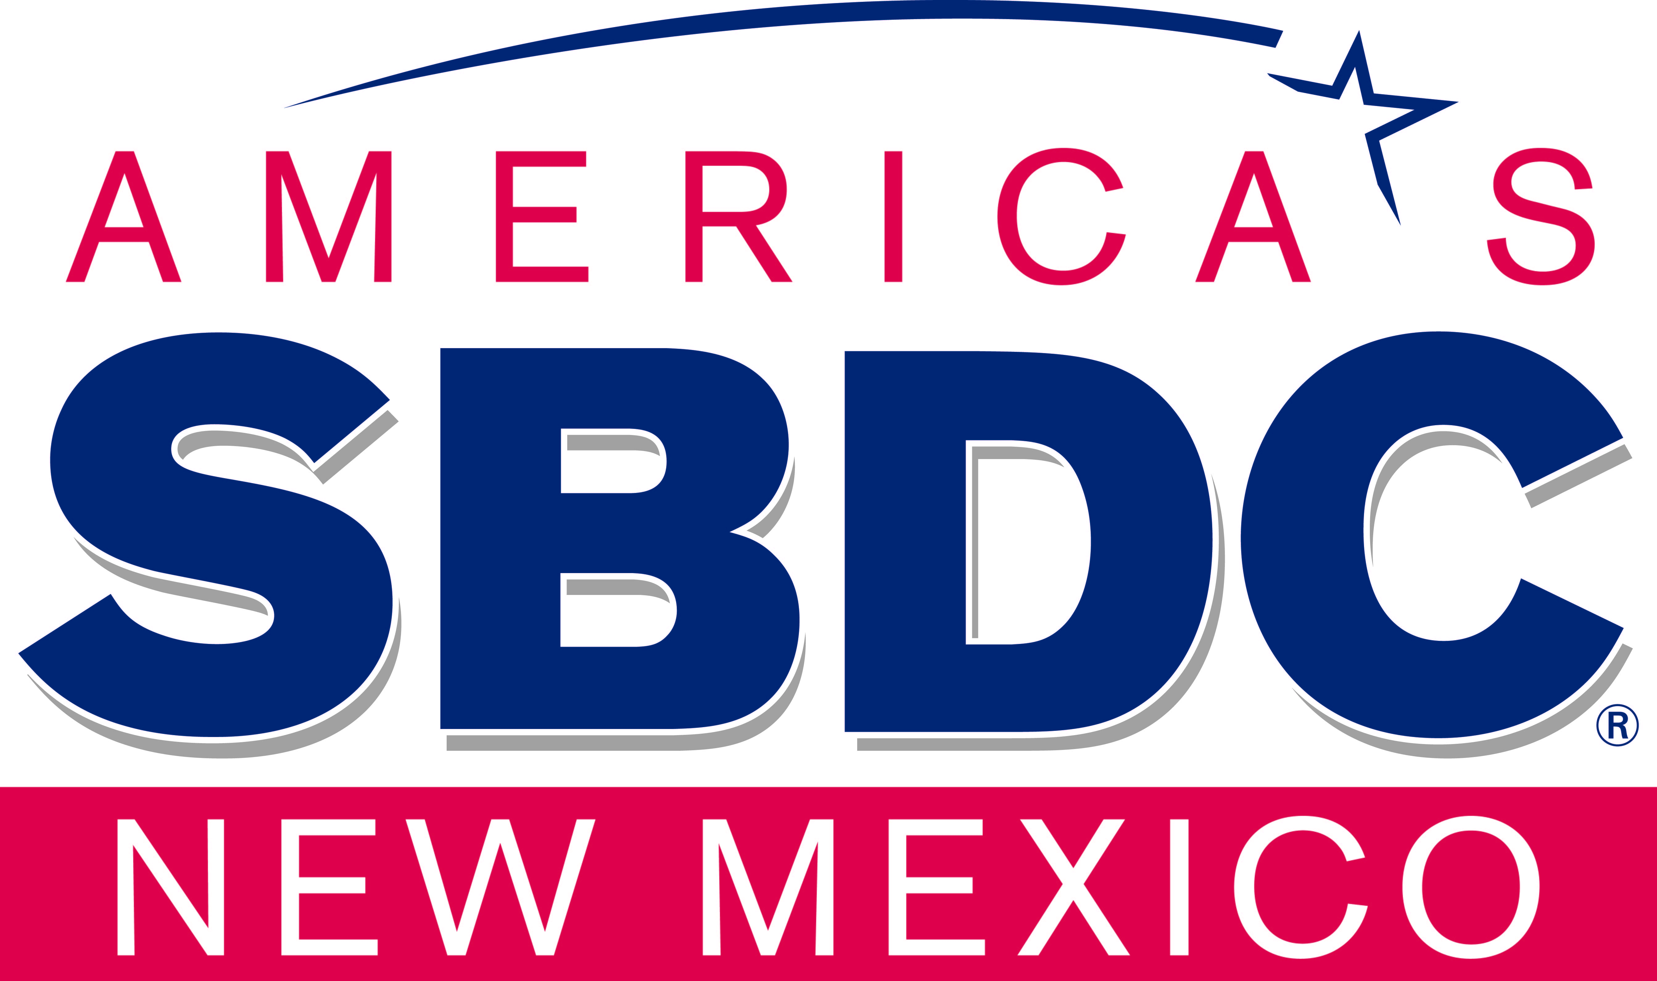
- July – Lead Center conducts the Statewide Advisory Board meeting and biennial new member orientation
- July – August - Regional meetings are held to obtain input from the NMSBDC Program funded staff of their review of the NMSBDC Program data for the SBP
- July – August - NMSBDC Executive State Director visits host institutions
- July – August – NMSBDC Associate State Directors conduct Subcontracted Service Center reviews
- August – September - NMSBDC Subcontracted Service Center Directors meeting is held to finalize inputs for the proposed changes to the SBP and the other Foundational Documents (FDs)
- September – Lead Center reviews inputs and prioritizes proposed statewide improvement opportunities action steps
Do October - December
- October - NMSBDC Lead Center receives and reviews the SBA OSBDC CY Funding Opportunity, adds statewide programmatic action steps and modifies the NMSBDC FDs as needed
- October – November NMSBDC Executive State Director finalizes and approves the FDs
- November – Lead Center releases and trains the FDs at the annual NMSBDC statewide program meeting
- December – Lead Center reviews and approves the NMSBDC Client survey
Study January - March
- January 1 – Lead Center activates the NMSBDC client survey
- January – NMSBDC Program Staff submit their calendar year professional development plan
- January – March – Lead Center conducts the Statewide Advisory Board meeting concerning the Program year
- January - March– Lead Center reviews, approves & conducts NMSBDC Program funded staff survey(s)
- January - March –Lead Center reviews, approves and conducts NMSBDC stakeholder, partner and community input methods
- January – March – NMSBDC Service Center Director meets with their service area SBA Resource Partners to create their calendar year training plan
Act April - June
- April – Lead Center collects, quantifies and trends the input data for analysis
- May - Lead Center sends Program data to Program funded staff for their review in preparation for their July – August Regional Meeting
- June – Lead Center holds a Data meeting via an Internet platform to review the Program data with the NMSBDC Program funded staff in preparation for the July – August Regional Meetings

