Certificate of Completion

This Acknowledges That

Has Successfully Completed The
NMSBDC New Hire Orientation Program

July 2015 |  | 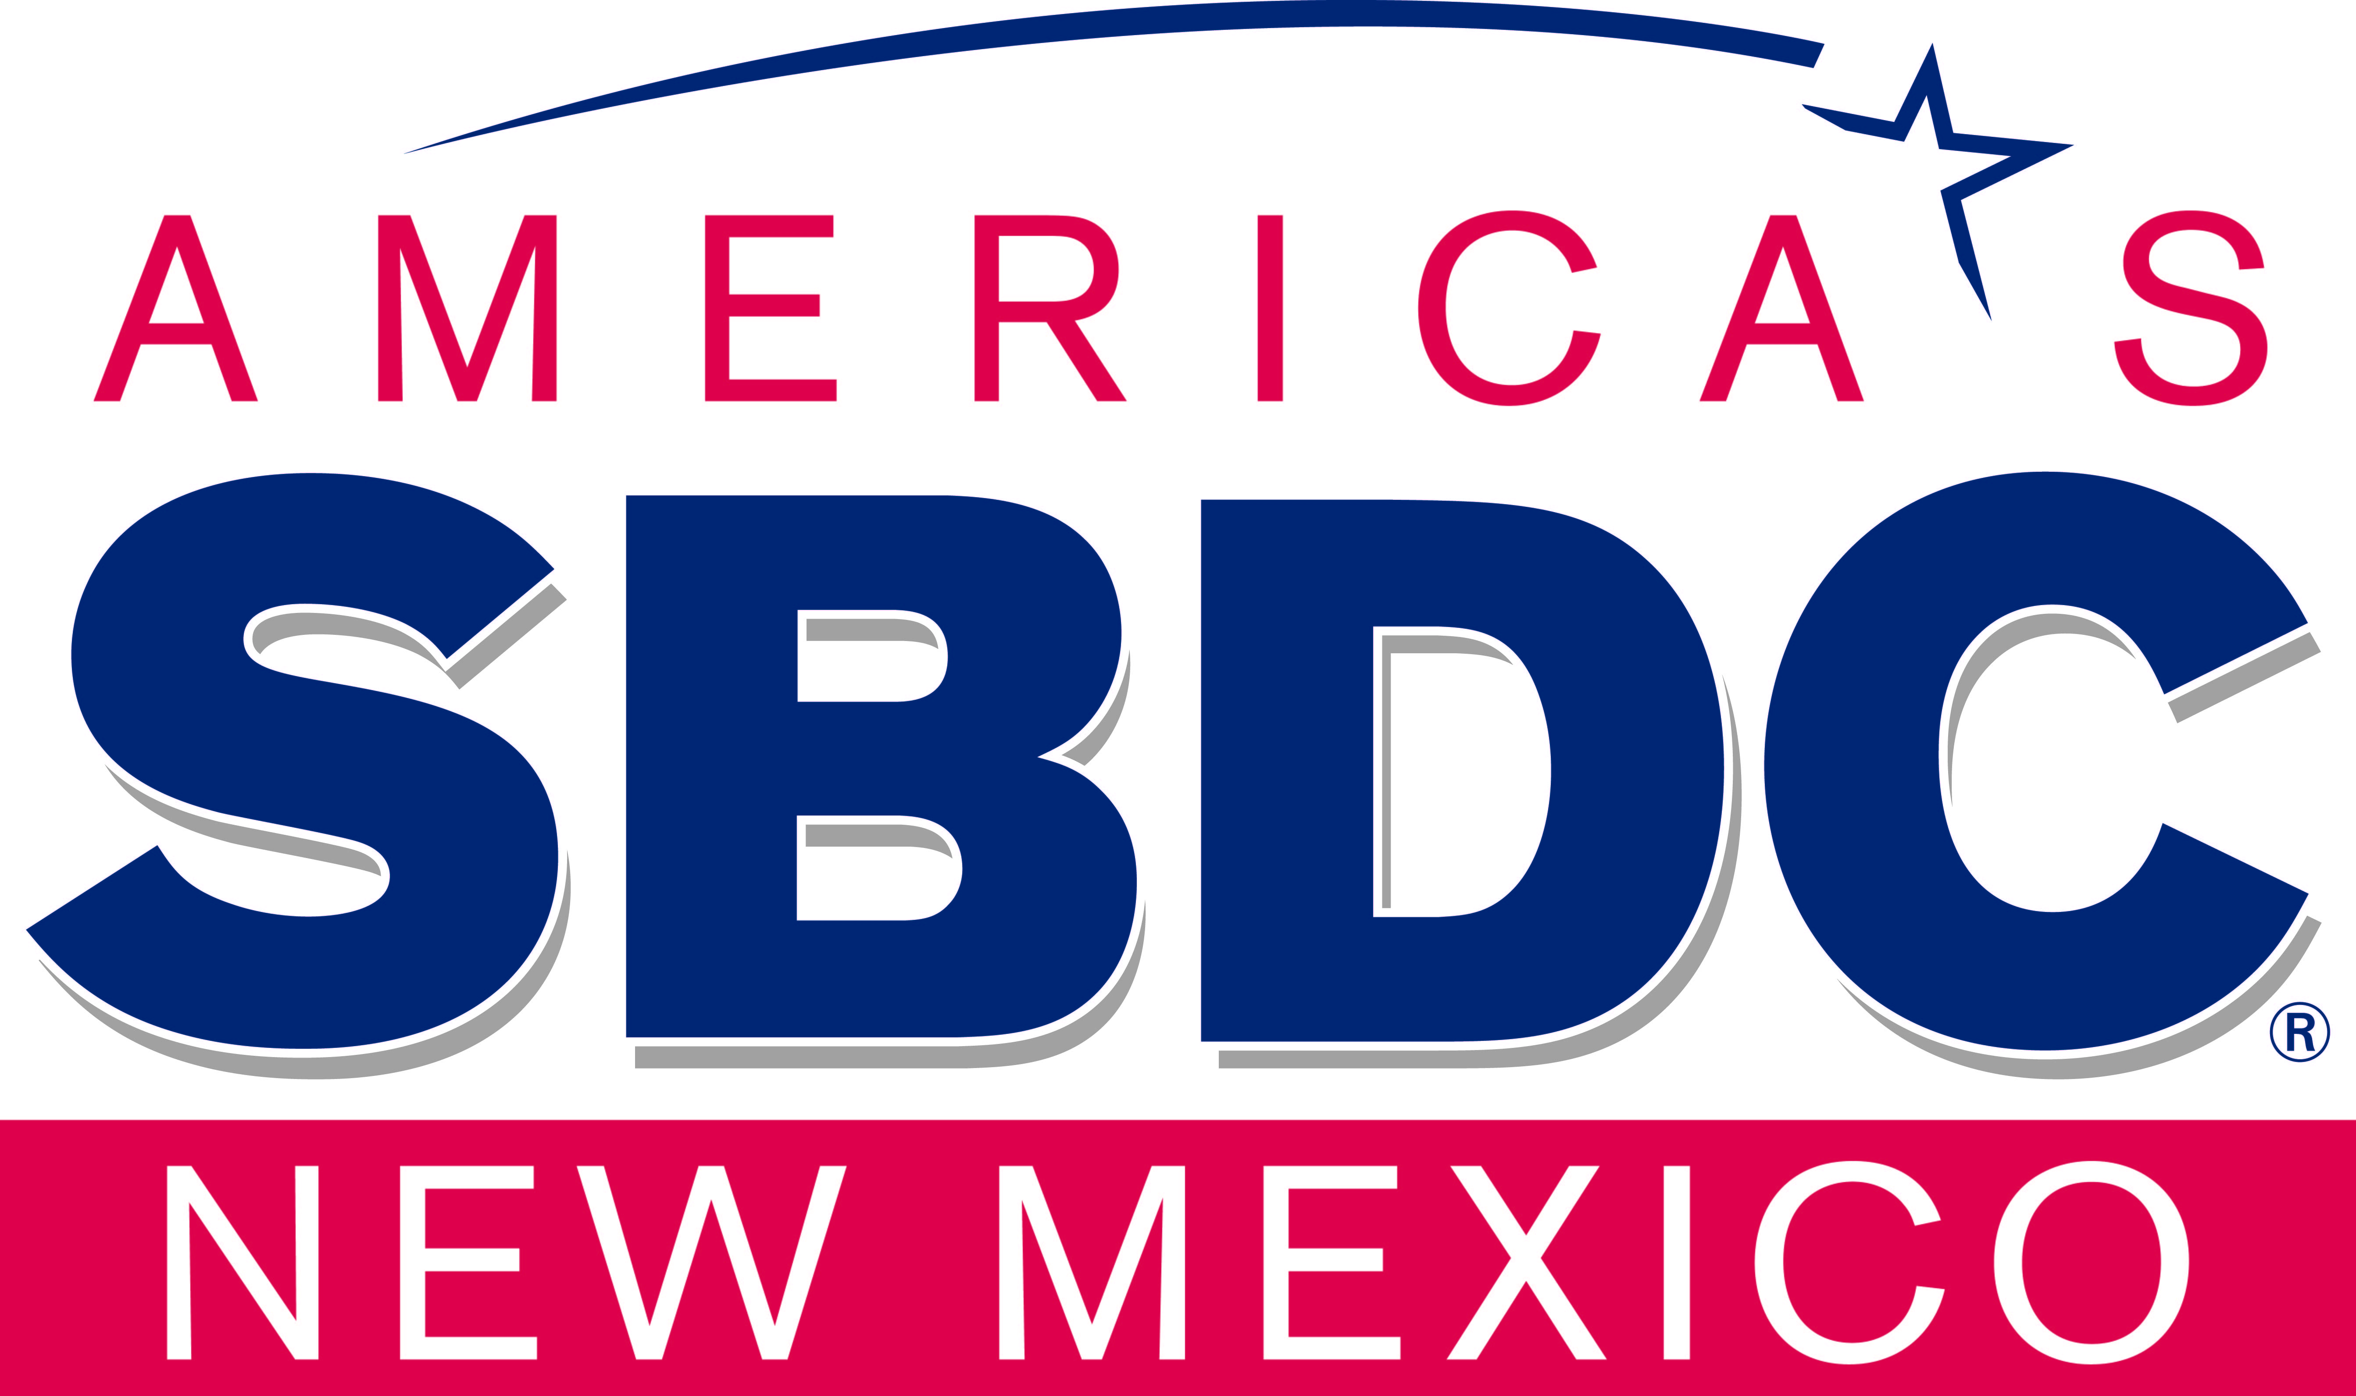
  Signed, Adriene Gallegos, Associate State Director – Program Development

