Certificate of Completion

This Acknowledges That

Has Successfully Completed The
Enter Title Here

Month / date  2020 |  | 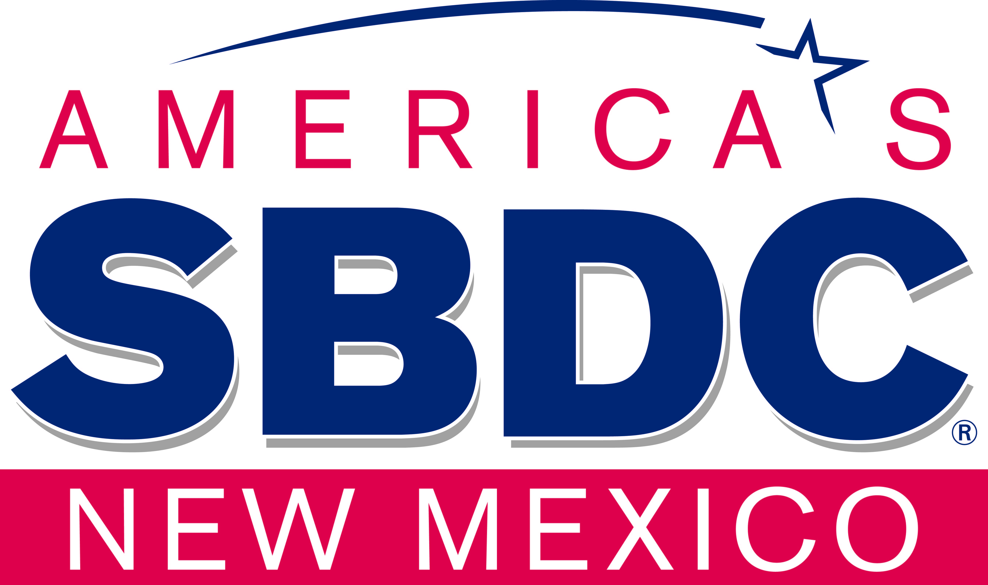
  Signed, Adriene Gallegos, Associate State Director – Program Development

