Workflow Author Guide

Prepared By:
Real Time Solutions
301 Central Ave NW | Albuquerque, NM 87103
Phone: 505.830.0414 | Fax: 505.830.0434

Login
Please follow these steps to log in:

1. Go to http://nmsbdc.org//admin
2. Enter your credentials
3. Login

Make Changes in Text Editor

- Go to page for editing
- Open Text Editor (using pencil icon)
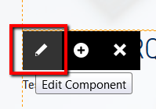
- Add Content
- Save Changes
- Save and Close when done

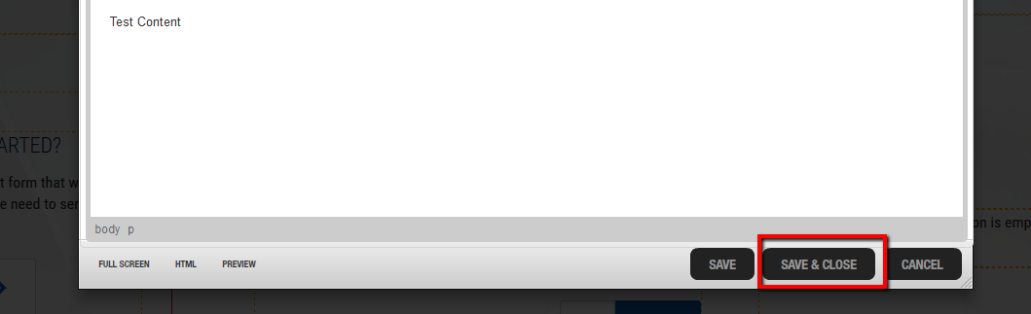
When you save a change, it will move into draft mode, indicated by a yellow question mark.



Submit for publishing
If you are ready, submit your change to the Publisher for Approval.
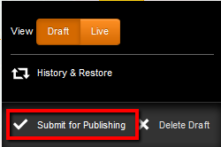

Changes awaiting approval are indicated by a red exclamation point.

Additional Draft Mode Options
In Draft Mode (Before submitted for Approval) you can:
Preview Draft, Delete Draft, or view History (past versions) here:
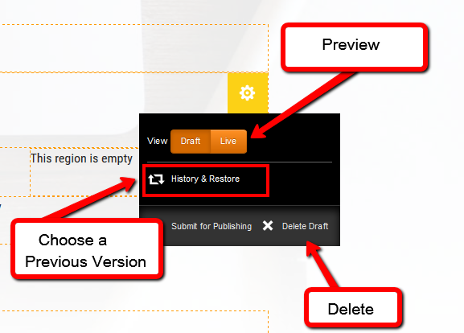

History & Restore
Preview versions of the content by pressing on a details button. It will launch a preview version.
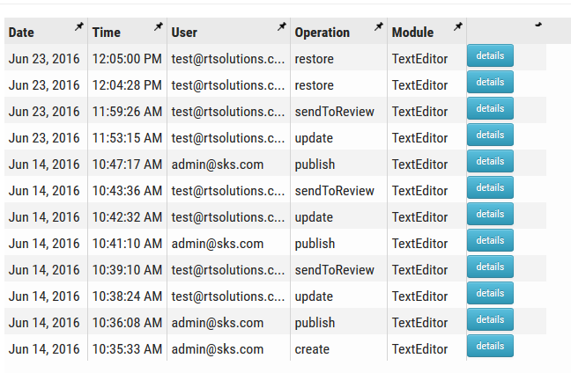
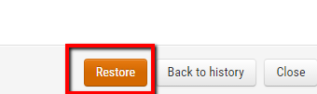
- Restore Previous Version by selecting Restore and choose to continue working on your draft.
- Once you are ready, hover over the yellow check box and submit it for publishing

