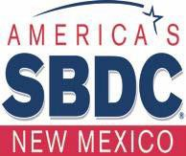
Attachment R
DISCLOSURE OF CLIENT INFORMATION (Media)

I , (please print) owner and/or legally authorized representative of

(name of business or organization) hereby authorize the New Mexico Small

Business Development Center (NMSBDC) Program to use my name, business name, location, phone number, and email address for promotional purposes. I also consent to release my photograph and photographs of my business or organization for news releases concerning my business to print, broadcast and social media outlets and for NMSBDC Program publications of my participation in NMSBDC’s Programs.

I understand that this information and these photograph’s may be used as a marketing and publicity tool by the NMSBDC Program and may be distributed to NMSBDC clients, members of the state legislature, representatives of the media and other interested parties. Further, I understand that the information provided will be general in nature and that financial information related to my business venture will not be disclosed.

I understand that I can continue to receive SBDC Program services whether or not I give the approval to release my information.

Signature of Owner or Legally Authorized Representative

Date

