Implementation Plan of Storybook
(Internal Page)

· Purpose: Serves as introduction to the SBDC
· Time: 5-10 Minutes
· When: Beginning of initial session
· Who: New clients or clients returning after several years (since rebranding has
occurred)
· Presentation: hard copy or PowerPoint form
· Customize: for each center highlighted in yellow on pages 1-4 and 9

Conversation Starters

o “I will take time to tell you about our story and then I would like to hear more about your story.”
o “I would like to introduce you to who we are.”
o Lay the groundwork for the initial session and in the beginning review who we are

WELCOME
to the
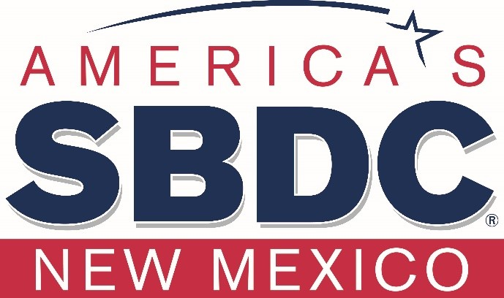

Small Business Development Center

Insert Host Logo Here

Building New Mexico’s Economy One Business at a Time

Small Business Development Center
at
Host Institution Name
Address
Phone Number
Website

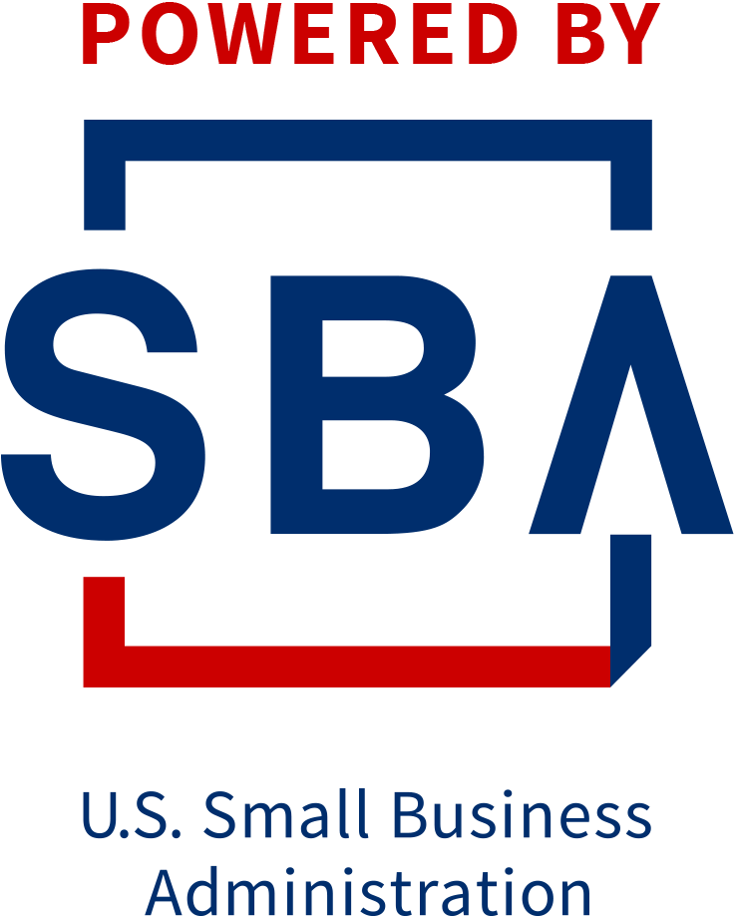
We are funded by the
State of New Mexico Legislature and the U.S. Small Business Administration

Our Mission
“To develop skilled entrepreneurs and strong businesses.”

New Mexico Small Business
Development Center
Lead Center
Santa Fe Community College

- Centers throughout New Mexico
- Our center serves: (enter your service area)
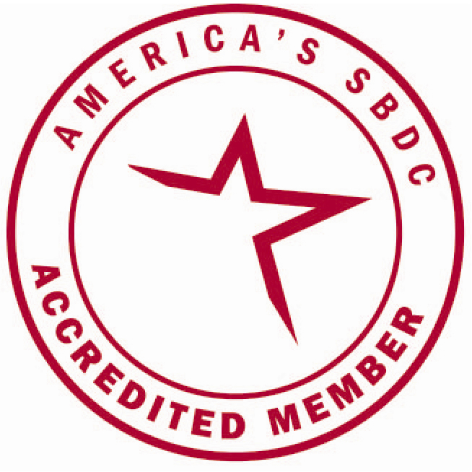
- Offices in: (enter your offices)
- NMSBDC Founded in 1989
- Nationally Accredited
- 1,000+ Small Business Development Centers nationwide including U.S. territories
- Network of over 40+ professional Business Advisors located at SBDC centers throughout New Mexico

Our Staff
Include each team members name, title, headshot and one sentence listing expertise.

Name
Title
Sentence listing expertise
Name
Title
Sentence listing expertise
Name
Title
Sentence listing expertise

What We Do
- Business consulting
  - Our professional consulting services are provided at no cost
  - All our services are confidential
  - Unlimited services to startup and existing businesses

- Business training
  - Low or no cost
  - Trainings are tailored to meet the needs of small businesses to help build skilled entrepreneurs

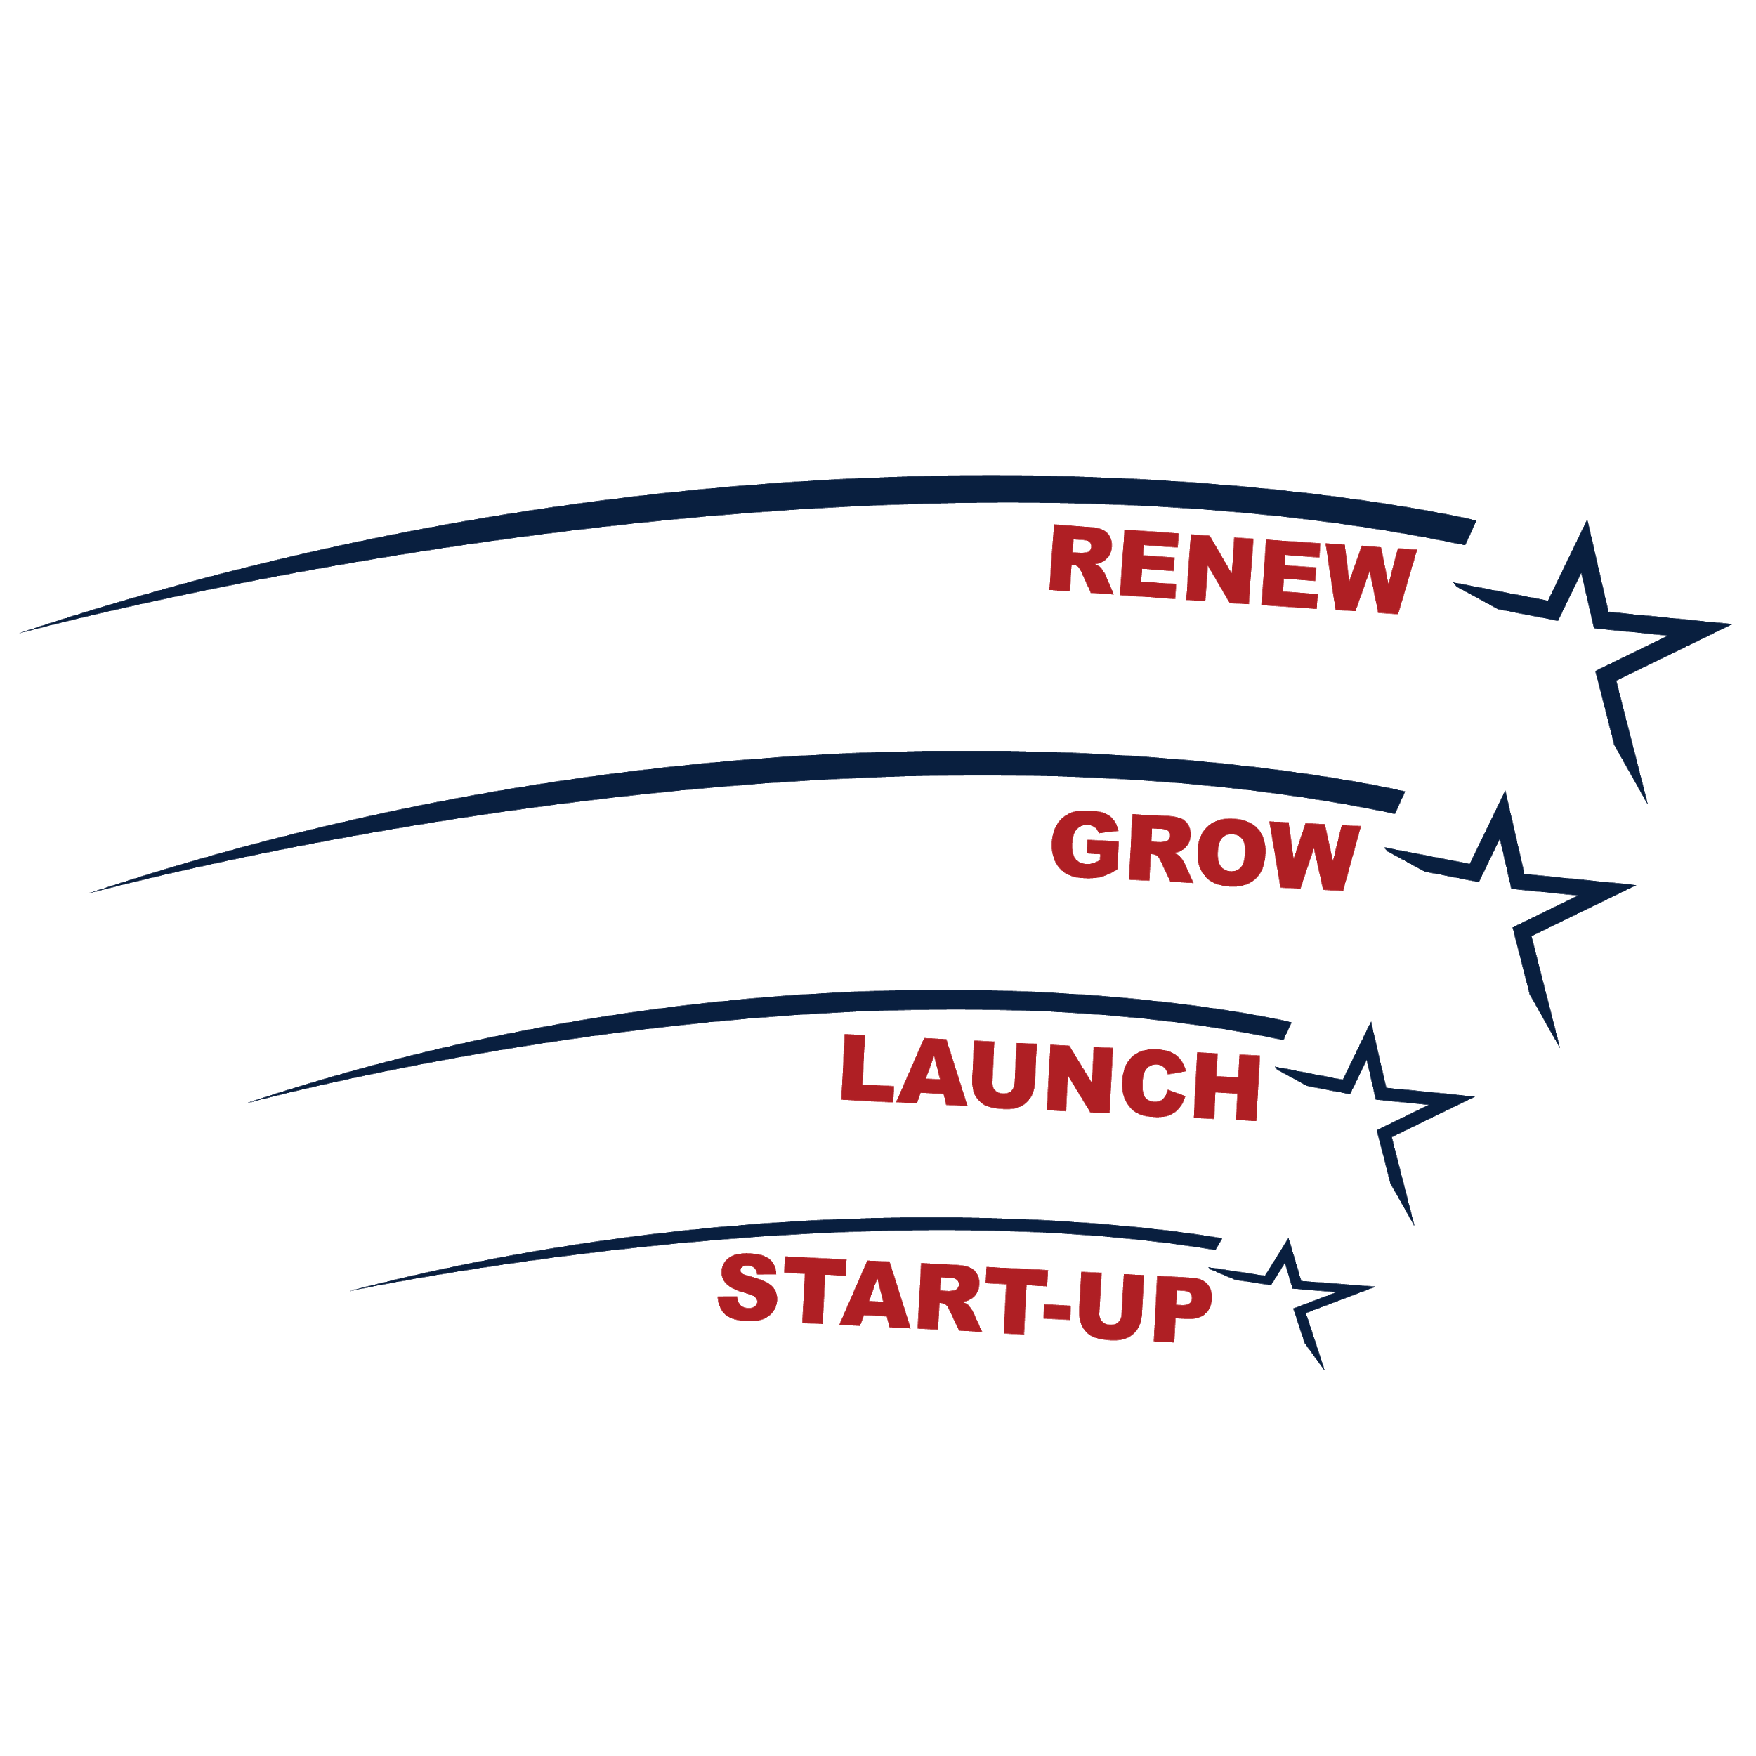

What We Ask You to Do
- The work necessary to succeed
- Make your own decisions
- Work with the SBDC business advisor

- Seek a professional accountant and/or attorney as needed

How We Measure
Our Success Together

The SBDC is successful only if our clients are successful. The only way we can measure this success is if our clients participate in providing feedback as followed:

- Surveys
You will receive requests to complete short surveys via email throughout the time you receive SBDC services.

- Economic Impact
When you start or expand your business, hire employee(s), or acquire capital for the business due to the assistance you received from the SBDC, you will be asked to fill-out and sign a Client Economic Impact Report.

- Letter of Support
If you appreciate our services, please share your experience with our stakeholders. We will provide you with contact information.



Other Programs

The NMSBDC Network hosts two other programs to further assist New Mexico business owners. Your business advisor can connect you with these programs.
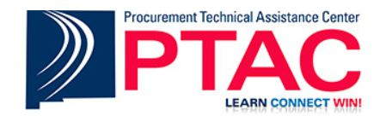

New Mexico PTAC provides government procurement assistance to small businesses who want to sell goods or services to the government, educational institutions, or tribal entities.

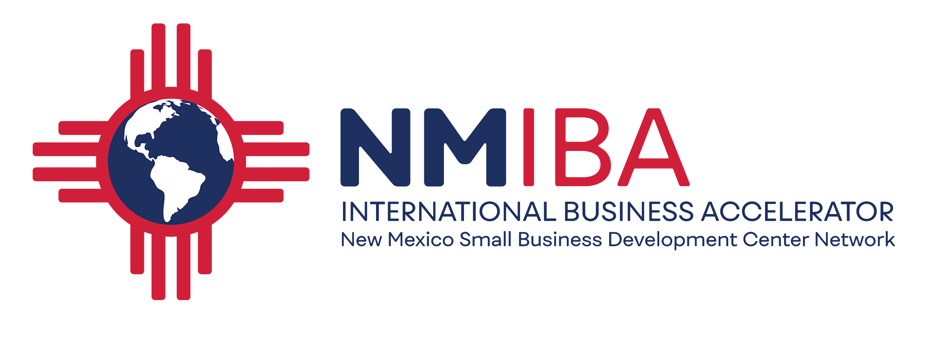

The International Business Accelerator is a one-stop shop resource for New Mexican businesses wanting to introduce their product or service into the global market.

*More Information

Center Specific Information

For more information about the statewide program please visit www.nmsbdc.org/(center site)

Recommendations: (add links on site)
- Social Media Accounts
- Newsletter
- Star Client, Other Clients, etc.
- Google Reviews

*Page must approved by NMSBDC State Director

Thank You!

