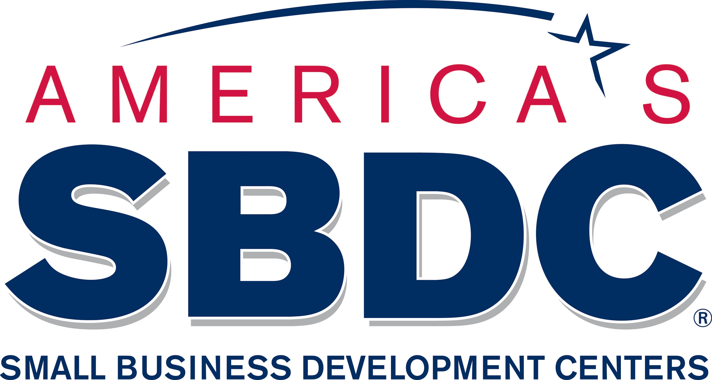

Tips for Businesses on Responding to the Impact of the COVID-19 Pandemic
(current as of 3/19/2020)

Things small business owners should consider and do right now so you’ll be better prepared to survive through the COVID-19 pandemic. These, incidentally, are smart preparations to undertake at any time, so you’re not wasting the effort.

1. Look at your financials and cash flow.
How long can you “make it through” in case of a quarantine, lost wages, employee absenteeism (when you are paying for sick leave AND not bringing in revenue). What do you need to bridge the gap? Plan on a 6-8 month drop in revenues. Map out cash flow now.

Get a credit line approved now. You don’t have to use it. But you’ll have it when you need it.

Aggressively pursue accounts receivables.

2. Slash your overhead.
If you’re worried about losing customers or employees due to sickness, school closures or possible quarantines, cut the things you don’t HAVE to spend your money on.

3. Communicate, Communicate, Communicate and Get Online!
Keep staff and customers informed and up-to-date on your operations. It’s important for businesses to keep in touch with customers to help maintain them through this incident. Let them know what steps you are taking to ensure a safe and clean establishment; what your open hours are and how to communicate with you; use email auto-reply with answers to frequently asked questions to help your customers get information quickly; offer alternative methods of good deliveries (curbside service, at home delivery, drive thrus, etc.).

Use online platforms, like Facebook and your website, to inform customers of your operating status and how to purchase your products or services. Communicate this information through direct email to customers and through social media such as Twitter. Make sure you have a Business Profile on Google. Postal mail might be a way for your message to get customers’ attention who are being bombarded with emails.

4. Understand your insurance policy.
What does your insurance cover? What doesn’t it cover? Business interruption insurance is insurance coverage that replaces business income lost in a disaster. Business interruption insurance is not sold as a separate policy but is either added to a property/casualty policy or included in a comprehensive package policy as an add-on or rider. If you don’t have business interruption insurance, it may be too late to help you in this emergency, but you should know what it is, how it works, and how much it costs.

A government mandated closure (hospitality businesses, for example) most likely will enable business interruption insurance to kick in.

5. Look at your supply chains.
Are they diversified or are you relying on one source for your products? Supply chain management is essential in any global pandemic. Travel, workforce absenteeism, and financials will impact supply chains across the world. It’s important you have multiple providers of a resource that is the core of your business. Consider partnering with other businesses to share a vendor contract. That will make your order larger and a higher priority to the provider and may help to reduce the costs of goods.

6. Develop an incident response plan.
What do you have in place in case of a quarantine? Can your employees work from home? Can you sell online or deliver instead of staffing brick and mortar? What kind of technology can be implemented to reach your customers? What communication is in place to your customers and employees?

Identify essential functions and cross-train employees now so several can perform those tasks. Consider what programs or services could temporarily be shut down.

Think about potential disruptions in supplies, services and transportation in the likelihood those organizations experience employee absenteeism. Identify alternative vendors / suppliers / etc. and how to reach them.
Store information on your employees, vendors, and clients in an online account so it’s accessible from any device.
7. Prepare for a disaster loan.
- Complete and assemble 2019 and prior year financial statements.
- Start documenting and forecasting the impacts of the situation.
In the past, SBA disaster loans have required many forms, can be confusing, and could take 3-6 weeks before receiving the money. Additional details on SBA Economic Injury Disaster Loans.

8. Practice Social Distancing!
Social distancing is a term applied certain action to stop or slow down the spread of a highly contagious disease. Here’s some action items you can implement quickly in your business:
• Encourage staying more than three feet apart
• Do not high five, shake hands or have close physical contact
• Wash your hands more frequently and use hand sanitizer
• Clean and disinfect your work and customer areas more frequently
• Avoid touching your face, nose, or eyes

It may seem silly to have to continue to tell your employees to – wash your hands, cover your mouth when you sneeze or cough. But the truth is, habits are hard to break. Printing signs on your office printer can help as subtle reminders to your employees and customers to practice better personal hygiene – key to recovery from this illness, according to the public health experts.

9. Encourage Good Hygiene.
Purchase hand sanitizer and encourage employees to start using it or washing hands per health agency guidance (alcohol-based hand sanitizer that contains at least 60-95% alcohol or wash hands with soap and water for at least 20 seconds). Begin a “no handshaking” protocol NOW so it’s ingrained in our daily routine if/when things get worse.
Encourage employees to regularly clean their work areas. Be prepared to do a thorough cleaning of your facility should you need to if employees are directly affected and have been on the property.
10. Dealing with COVID Exposure
- Employees who are well but who have a sick family member at home with COVID-19 should notify their supervisor and refer to CDC guidance for how to conduct a risk assessment of their potential exposure.
- If an employee is confirmed to have COVID-19, employers should inform fellow employees of their possible exposure to COVID-19 in the workplace but maintain confidentiality as required by the Americans with Disabilities Act (ADA). Employees exposed to a co-worker with confirmed COVID-19 should refer to CDC guidance for how to conduct a risk assessment of their potential exposure.

11. Reevaluate your sick leave policies.
Under pandemic circumstances employees should be encouraged to stay at home beyond their currently authorized sick leave. Also take the time now to review what additional benefit options might be available to support and continue paying employees beyond usual sick leave periods when they may be infectious or need to stay home to take care of family members. An example would be “borrowing” sick leave from the next year, or providing “administrative leave.” Another approach is to establish special provisions just for COVID-19 circumstances.

12. New Paid Sick Leave Requirements.
Businesses with 500 OR FEWER EMPLOYEES must provide:
- paid sick leave – 2 weeks paid leave at 100% of employee’s normal pay, up to $511 per day.
- paid family and medical leave – additional 12 weeks of paid family and medical leave at 67% of normal pay, up to $200 per day (small businesses can apply for a waiver of this in some limited circumstances).
- Small businesses will get a tax credit to cover these costs.
- Gig workers and independent contractors will get the same benefits in form of a tax credit.
Small businesses: you must provide paid sick leave and/or family/medical leave for any of your payroll workers (not contractors). The Federal Government will pick up the cost of this paid leave—by applying a credit for your 6.2% payroll social security taxes. If the credit is insufficient to cover those costs, the Federal Government will pay you directly. You or your workers do not have to be sick to qualify! Anyone told to quarantine, who is exposed to the virus, showing symptoms, or needs to get tests or preventive care qualifies. Family leave is easier—up to 3 months of paid leave to adhere to quarantine, take care of a sick family member or a child who is home because of their school being closed.
Gig worker/independent contractor: if you are paid by another company (e.g., a ride share company, a caterer, a worker platform like Upwork, another contracting company), you’re eligible for a tax credit of up to 2 weeks sick leave at your average pay and 12 weeks of family/medical leave at 2/3 your average pay. The same caps apply--$511/$200 per day. You must show you had to comply with self-isolation or care for family members, including children whose schools had been closed due to the coronavirus. Tax credits will be applied against your tax payments, or you will get a rebate if your tax is lower than the credit.
13. Plan.
Even if you’re not currently negatively impacted by the COVID-19 pandemic, you could be in the future depending upon circumstances, or you could face another type of business interruption. If you are in this situation, use your time now to develop a disaster recovery plan.

14. A Request.
If you are planning a large event, small event, or a gathering…try not to cancel those events. The other small businesses you are working with depend on that cash flow too to survive. Rather, look at your contracts and see if you can reschedule the event for later in the year when this crisis subsides.

