Welcome to The Intentional Entrepreneur

TABLE OF CONTENT

The Intentional Entrepreneur . . . . . . . . . . . . . . . . . . . . . . . . 1

ASSESS Your Entrepreneurial Interest . . . . . . . . . . . . . . . . . . . . 2
TOOL 1 Entrepreneurial Characteristics Survey . . . . . . . . . . . . 4
TOOL 2 Looking Inward . . . . . . . . . . . . . . . . . . . . . . . 6

ALIGN Your Personal Priorities and Professional Goals with Your Vision . . 8
TOOL 3 Identify Your Personal Priorities . . . . . . . . . . . . . . . 10
TOOL 4 Identify Your Professional Goals . . . . . . . . . . . . . . . 12
TOOL 5 Create Your Long-Term Business Vision . . . . . . . . . . . 14

Start small – THINK BIG
Generating Ideas and Defining Your Business . . . . . . . . . . . . . . . . 16
TOOL 6 Generating Ideas . . . . . . . . . . . . . . . . . . . . . . 18
TOOL 7 Development and Evaluation of Business Ideas . . . . . . . 19

MAKE IT HAPPEN
Identifying Action Steps Toward Business Ownership . . . . . . . . . . . 22
TOOL 8 Networking for Business Success . . . . . . . . . . . . . . 24
TOOL 9 My One-Year Vision . . . . . . . . . . . . . . . . . . . . . 26
TOOL 10 Actions, Insights and Resources . . . . . . . . . . . . . . . 28
The Intentional Entrepreneur is for those who dream of owning their own
business – those who have the desire to create their own future, to realize their passion through business ownership; those that want to bring something of value to themselves and society.

We all know those who never make the leap. Whether due to packed schedules, lack of resources or abilities, or simply being unsure of how to proceed, they can’t
seem to get off the mark. The bottom line is that the thought that “I’ll do it someday” is one many have had only to discover that “someday” never came.

This course has been designed to help you move forward – To take action. The Intentional Entrepreneur is an innovative program designed to help you investigate your entrepreneurial attitude by exploring both the emotional and practical aspects of business ownership. The tools in each section have been designed to help you assess the sometimes conflicting nuances between what is in your heart and what is in your head, ultimately bringing you to a decisioN with regard to your entrepreneurial future.

“You are not here merely to make a living. You are here in order to enable the world to live more amply, with greater vision, with a finer spirit of hope and achievement.
You are here to enrich the world, and you impoverish yourself if you forget the errand.”
Woodrow Wilson

The Intentional Entrepreneur

Do you think you have what it takes to succeed as an entrepreneur? If you are like many,
business ownership is an idea that you have flirted with over time. The idea of owning
your own business, controlling your own destiny, making decisions and charting your own
path is very compelling. Whether it is spending time doing something you are passionate
about or finding a way to supplement your income, entrepreneurship is a valid opportunity
to pursue your dream.

One of the most important aspects of business success is to be an intentional entrepreneur
instead of an accidental entrepreneur.

in·ten·tion·al [in-ten-shuh-nl]
adjective: done with intention or on purpose; intended

Synonyms Antonyms
1. designed, planned. See deliberate. 1. accidental.

Intentional entrepreneurs define clear objectives and goals for themselves and take
the time to craft a plan and then implement the plan. They are focused and determined.
Perhaps most importantly, intentional entrepreneurs understand and appreciate their
motivation and drive toward an entrepreneurial lifestyle. They understand the things
that excite them and that they can get passionate about doing. Whether they are running their own business or helping an organization think entrepreneurially as an “intrapreneur” these people recognize their strengths.

Accidental entrepreneurs are those that fall into entrepreneurship as an afterthought
putting little or no structure around their business. The business is often a placeholder
activity used until something better or more interesting comes along – A sort of “plan B.”
Unfortunately, “plan B” often can run for years and, for the entrepreneur, the frequent
missteps that occur due to a lack of planning can become very costly.

Whatever leads you to investigating entrepreneurship is fine as long as you set clear goals and objectives for yourself – acting and moving forward as an intentional entrepreneur. Get ready for the journey of a lifetime!

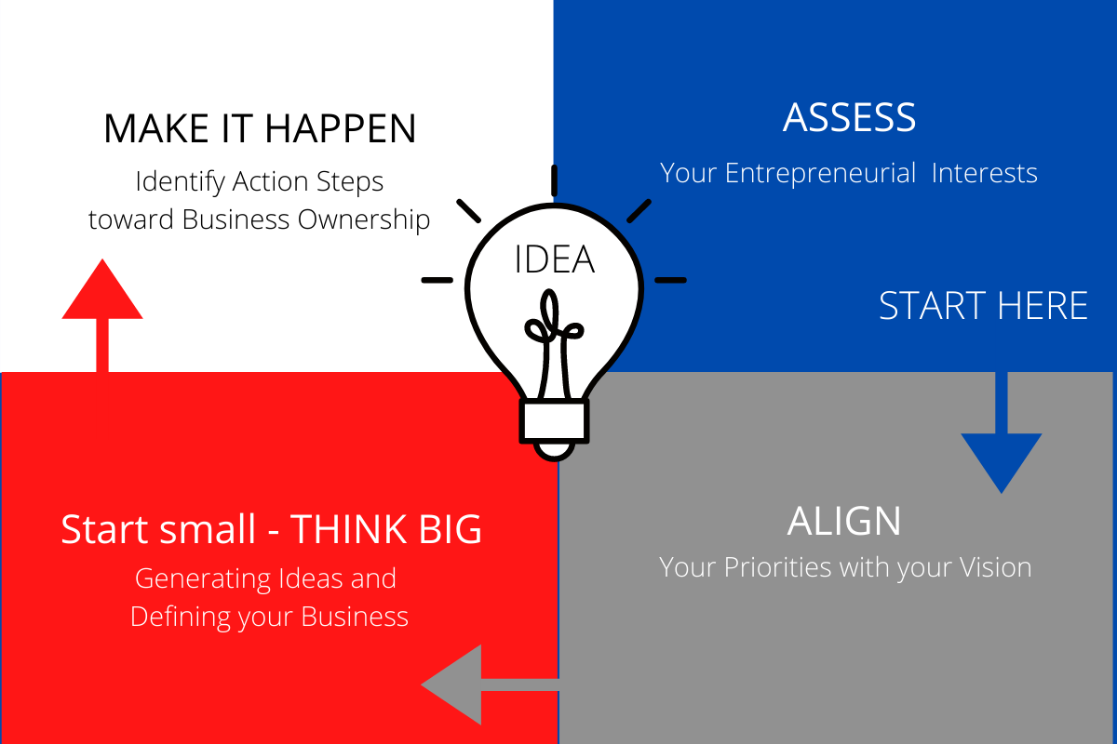

What it takes to be an Intentional Entrepreneur

ASSESS Your Entrepreneurial Interest
- TOOL 1 Entrepreneurial Characteristics Survey
- TOOL 2 Looking Inward

ALIGN Your Personal Priorities and Professional Goals with Your Vision
- TOOL 3 Identify Your Personal Priorities
- TOOL 4 Identify Your Professional Goals
- TOOL 5 Create Your Long-Term Business Vision

Start small – THINK BIG Generating Ideas and Defining Your Business
- TOOL 6 Generating Ideas
- TOOL 7 Development and Evaluation of Business Ideas

MAKE IT HAPPEN Identifying Action Steps Toward Business Ownership
- TOOL 8 Networking for Business Success
- TOOL 9 My One-Year Vision
- TOOL 10 Actions, Insights and Resources

ASSESS Your Entrepreneurial Interest

In this first section you will assess your entrepreneurial interest by:
• TOOL 1 – Entrepreneurial Characteristics Survey
• TOOL 2 – Looking Inward

Thinking about starting a new endeavor can be daunting, a little scary and quite exciting and thrilling. Giving life to a dream may feel as if you are exposing a part of yourself – putting it “out there” for all to observe. As Martin Luther King once said “Take the first step in faith. You don’t have to see the whole staircase, just take the first step.” Entrepreneurs who are willing to take the first step and investigate their ideas are those who will likely be successful in the future. As you work through the tools in this first section, allow yourself to think, dream and discover without any bias or paradigms. Think about your unique skills and abilities. Allow yourself to see the special things you bring to the table. Intentional entrepreneurs have what it takes to succeed – passion, confidence, a strong backbone, and self-discipline. They move forward with focus, creating solid plans for future business success and then acting on those plans. More importantly, intentional entrepreneurs recognize that they must use various tools, such as those discussed in this workshop, as a foundation for success. Any of the tools as stand-alone activities are good but to be truly successful you will need to use all the tools available to position yourself for success. If you want to pursue life as an entrepreneur, you will need to invest time and energy to acquire these and other traits.

What you bring to the table (write in the space below)

Entrepreneurial Characteristics | Strong | Average | Improvement
a Desire and Passion | 3 | 2 | 1
I have a fervent drive to succeed
and zeal for the tasks required.
b Energy | 3 | 2 | 1
I have stamina to tackle problems.
c Ability to Thrive on Uncertainty | 3 | 2 | 1
I can prosper in an environment
with many questions and few answers.
d Determination and Resiliency | 3 | 2 | 1
I can hang on in hard times and recover quickly.
e Accountability | 3 | 2 | 1
I take responsibility for my own success.
f Persuasiveness | 3 | 2 | 1
I convincingly communicate with others
—bankers, vendors, employees.
g Self-Discipline | 3 | 2 | 1
I can do the tasks necessary to succeed,
whether pleasant or unpleasant.
h Self-Confidence | 3 | 2 | 1
I believe that somehow I can solve
whatever problems arise.
i Social Responsibility | 3 | 2 | 1
I am passionately motivated to share
success and wealth by giving back.
j Ethics | 3 | 2 | 1
I deal with others with honesty and integrity.

Entrepreneurial Characteristics | Strong | Average | Improvement
k Ability to Value Appropriate Control Systems | 3 | 2 | 1
I value the management and control systems
necessary to run a business.
l Problem Solving | 3 | 2 | 1
I have an ability to anticipate
and troubleshoot problems.
m Networking | 3 | 2 | 1
I connect with others and
build strategic relationships.
n Market Awareness | 3 | 2 | 1
I can scan the marketplace and
assess potential needs and gaps.
o Low Support Needs | 3 | 2 | 1
I provide for my own needs
with little support from others.
p Business Knowledge | 3 | 2 | 1
I have a basis for making effective,
profitable business decisions.
q Good People Judgment | 3 | 2 | 1
I can pick the right people to
help execute my vision.

Scoring
I. Tally the number of times you circled “3”: _____ x 3 = _____
II. Tally the number of times you circled “2”: _____ x 2 = _____
III. Tally the number of times you circled “1”: _____ x 1 = _____
_____ Sum (I + II + III)

Your Score May Indicate:

1 – 17 POINTS Entrepreneurship may not be your thing. But that doesn’t mean that you don’t possess an entrepreneurial spirit Bring forth your innovative creativity within the context of someone else’s firm and serve in an “intrapreneurial” capacity to help that organization grow and thrive Create a personal vision to help clarify and focus your future goals

18 – 34 POINTS You might be an entrepreneur. Spend some time thinking about your entrepreneurial profile Document a personal vision for yourself that captures the lifestyle you desire, including the time you have for the business, the place you want to work, your family’s involvement, and your financial goals Make sure it also reflects your professional aspirations, including the type of work you enjoy, future professional goals, and the role you wish to play in the business By identifying your personal vision, you will be able to determine whether your business concept is a good match
35 – 51 POINTS You ARE an entrepreneur. With proper planning and consideration, you are driven and rewarded by innovation and problem solving You, too, should document a personal vision And, don’t do it alone Surround yourself with others – mentors, advisors, peers, associates, investors – who buy into your vision and will serve as a sounding board and support mechanism to help you ensure long-term success for the company you create

This survey is simply an indicator of your entrepreneurial tendencies – it is not an absolute predictor of failure or success but rather a compass to help you navigate how best to achieve your personal goals.

ACCESS Your Entrepreneurial Interests

Tool 2 - LOOKING INWARD

Looking Inward

Think through your responses to the survey
Spend a few minutes answering the following questions

What are your strengths?

Which areas of the survey indicated an opportunity for improvement? In which areas would you like to make some adjustments?

What would others say your skills and talents are?

Where have you received positive recognition and/or awards over your lifetime?

What are your hobbies and interest areas?

What businesses might capitalize on your strengths and interests?

Taking time to assess your areas of strength and interest will help you as you move forward Additionally, being aware of areas where you aren’t strong is also important, allowing you the time to commit to improving those skills or finding partners, staff, contractors or others to make up for your deficiencies and complement your skillset

ALIGN Your Personal Priorities and Professional Goals with Your Vision

In this second section you will define your personal preferences and start to craft
your personal entrepreneurial landscape by:

- TOOL 3 Identify Your Personal Priorities
- TOOL 4 Identify Your Professional Goals
- TOOL 5 Create Your Long-Term Business Vision

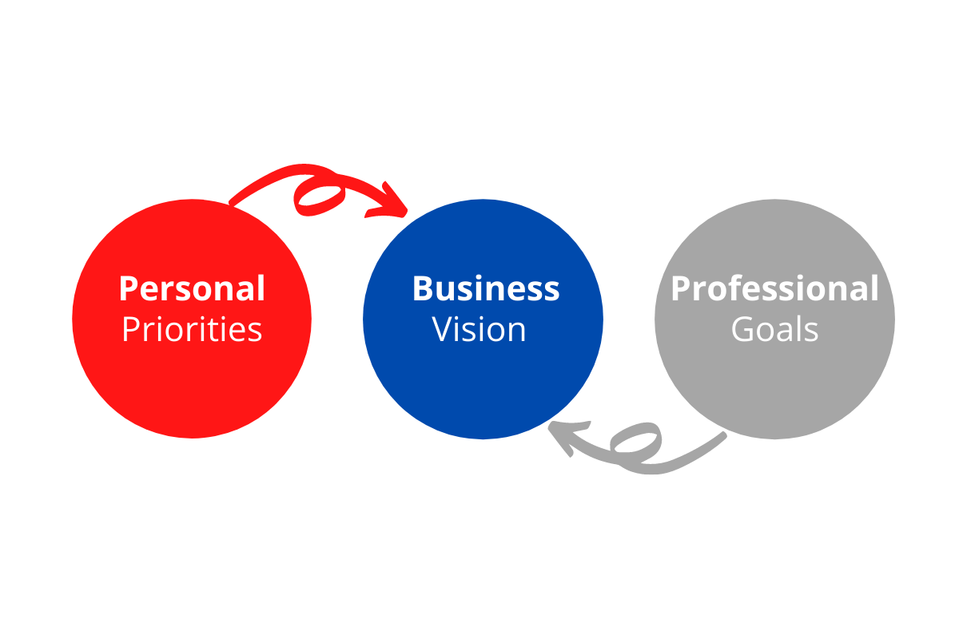
The decision to launch a business is a major consideration. While business ownership can be invigorating, interesting and thrilling it can also be an intensive, frustrating and demanding time. It is important that you think critically about what business ownership means to you, your family and your lifestyle. It is also important that you think about your professional goals and assess whether entrepreneurship will allow you to meet the goals you have set for yourself. Successful entrepreneurs recognize that their business vision must have roots in a solid foundation of alignment between personal and professional goals.

As you work through the tools in this section, ask yourself – “How is business ownership
going to fit within the parameters of my life?” “What choices might I need to make in
order to pursue my dream?”

Tool 3 - IDENTIFY YOUR PERSONAL PRIORITIES

When defining your personal priorities you have several choices to consider. Do you want to launch a company that has the potential to grow quite large? Do you see yourself running a national or multinational organization or would you rather concentrate on something smaller? Do you wish to operate independently or do you envision having a team?

Do you want to travel or are you happiest working in your office? Consider these and other important issues when thinking about your business. Being clear on your personal priorities is a positive step forward in creating a business that is right for you.

Work hours
What days of the week and the times of the day do you want to work?

Flexibility
How much flexibility do you want/need in your schedule?

Desired location
Where do you want to live and work? Will your business idea allow you to be flexible with regard to your location?

Education
Are there some skills or information that you want/need to acquire?

Travel
Do you want to travel?
Do you not want to travel?
Do you have limits on how much you are willing to travel?

Morals, Beliefs and Standards
Do you have a set of moral beliefs and standards which will inform the type of business you wish to own?

Physical Requirements
Do you have any physical requirements or limitations that need to be considered?

Family Involvement
How might business ownership impact/affect your family?
Will your family be involved?
Will they be supportive?

TOOL 4 - IDENTIFY YOUR PROFESSIONAL GOALS

Entrepreneurship can bring you a tremendous amount of professional opportunities –
From the places you go to the people you meet, entrepreneurship can be an exciting
and an engaging way to live your life. It is important to make sure that you clearly evaluate whether an entrepreneurial lifestyle fills your professional and financial goals.

Power or Status
Do you enjoy being the one in charge?
Would you rather be the leader or the person taking direction?

Daily Operations
How involved do you plan to be in the daily operations?
Do you anticipate having a team or staff?
Do you plan on having a co-founder?
Would you be happier being a “solopreneur,” only relying on yourself to run and operate the business?

Expertise, Skills, and Preferences
What skill sets might you need others to bring to the table?
What areas do you plan on building your own expertise and knowledge base?

Future Professional Goals
Where do you see yourself 5 or 10 years in the future?
Is the business you are considering in alignment with your future goals?

Personal Financial Obligations
Will the business be able to provide for your financial needs and obligations now
and in the long term?
Is this an endeavor you might wish to pursue for years to come?

Exit Plan
How long are you planning on operating the business?
What is your motivation for starting the business?
Is it to build a business with an eye on selling for a profit or do you want to leave
the business to family as a legacy?

Personal Investment
How might you consider funding your business?

TOOL 5 - CREATE YOUR LONG-TERM BUSINESS VISION

Business Vision Statement
A vision statement is sometimes referred to as a picture or idea – in this case an idea of
your company in the future. Your vision statement serves as your inspiration providing a
framework for strategic planning. Keep in mind a vision statement doesn’t tell you how
you are going to get there but rather is a statement that helps you articulate your dreams.

“If you can dream it, you can do it.”
— Walt Disney

Review your answers to Tools 3 and 4. Based on the information you provided,
write a short statement about your long-term business vision. Describe your business
and the customers you will serve, and the products/services you will provide.

Does your vision statement adequately reflect what success means to you?

Are there any parts of your vision that are non-negotiable?
(Things such as amount of travel, time commitment, etc.)

Start small-THINK BIG Generating Ideas and Defining Your Business

In this third section you will start to define your business by:

- • TOOL 6 – Generating Ideas
- • TOOL 7 – Development and Evaluation of Business Ideas

In today’s competitive and complex marketplace business success is far from guaranteed. Success takes focus and drive – and sound planning. Understanding and applying essential tools can reduce the many risks of entrepreneurship.
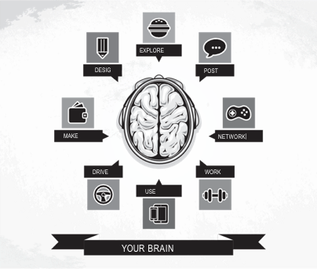
Identifying your entrepreneurial characteristics and aligning your personal/professional
goals with a vision is just the beginning. It is necessary to generate and develop business ideas and then investigate the feasibility of those ideas. It is also critical to engage a network of support to help you as you build your strategy. In today’s competitive and complex global marketplace, business success takes careful planning and thought and you don’t want to have to go it alone.

TOOL 6 - GENERATE IDEAS
You have identified your entrepreneurial characteristics. You have done some soul
searching and looking inward to better understand your natural strengths and abilities.
You have also identified your priorities and vision. Now is the time to expand your
thinking – get your creative juices flowing. Start thinking entrepreneurially…

Savvy entrepreneurs identify business ideas by being alert to consumers’ needs, wants,
problems and frustrations. They see the world through a lens of opportunity – one of
problem solving. Review steps 1 and 2 below and begin recording your ideas. Come
back to this activity in a day or two and continue recording new ideas.

STEP 1 Idea log. Start a log of possible ideas for a product or service by observing
what is going on around you. Look closely at your local community. What frustrations
have you and others experienced the marketplace? What unfulfilled wants or needs
do people have? What opportunities are identified in magazines or newspapers?

Idea Source of the Idea How Idea Identified
Brief Description of idea | Need? Want? Problem? Frustration? | Observation? Talking with others?
EXAMPLE
In-home care for aging parents | Need | Personal observation

STEP 2 Summary. Of the many ideas noted on your Idea Log, which ones appeal to you the most and why? Are the most appealing ideas in alignment with your business vision?

TOOL 7 - DEVELOP AND EVALUATE BUSINESS IDEAS

If you are like most people, some of the items on your Idea Log have definite potential.
Some may hold a great deal of interest for you. Use a mind map to “expand” and think
a bit deeper on one of your ideas. Take the idea beyond a simple statement to show
more detail around the business. For example, what services might be needed by seniors looking for in home care?

Your Business Idea
Draft a mind map for your business idea. Don’t be afraid to add and delete to best
accommodate your idea. Let your mind move freely as you work through this tool.
There is no right or wrong answer. Let your ideas flow freely.

Evaluation of Business Idea

What skills and abilities might you need to acquire to implement this idea?

Does there seem to be a viable market for this idea?

If so, what do you think will give the business a competitive edge?

Does the business fit well with your personal vision?

Are the risks associated with this business acceptable to you?

MAKE IT HAPPEN - Identifying Action Steps Toward Business Ownership
In this fourth section you will further define your business by:

• TOOL 8 – Networking for Business Success
• TOOL 9 – My One-Year Vision
• TOOL 10 – Actions, Insights and Resources

Now that you have made a preliminary assessment of your potential business, it is necessary to develop transition tactics to enhance your skills, move the business forward, and achieve success. This last section – Make it Happen – Identifying Action Steps Toward Business Ownership – will help you identify specific tactics necessary to meet your one-year vision.

You will walk out the door today knowing exactly the first items you must address.
As you work through the tools in this section, keep in mind that it is not enough to set
goals. You must diligently work toward them, measure your progress along the way
and make the necessary improvements. The idea is to take your goals and move them
from your “bucket list” of someday to your “transition” list of today – make it happen!
Goals for your business should be SMART:
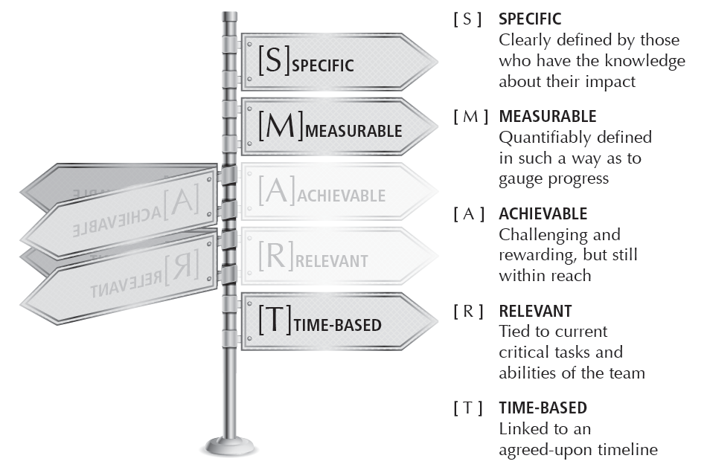
You will increase your odds of achieving your goals if you commit to them in writing.
You’ll find that using the SMART approach will help improve your goals setting skills.

TOOL 8 - Networking for Business Success

Defining and planning how to leverage and engage a network of support.

“Engage your network… Everyone wants to help!”
— Alana Muller, author, Coffee Lunch Coffee, A Practical Field Guide for Master Networking

As an entrepreneur, making personal connections is one of the most important aspects of leading, owning and running a successful business. While networking takes time, effort and a certain amount of “putting yourself out there,” it is critical to your business success and is one of the most powerful things you can do. Whether your business idea is a consulting firm, a restaurant or a technology company, it is all the same. You will benefit from relying on a network of contacts – people doing business with people, rather than companies doing business with companies. People are really what it’s all about.

Answer the following questions to evaluate your personal network to determine how
members can contribute to your entrepreneurial venture.

STEP 1 Identify resources.
From your circle of family, friends and professional connections, identify which individuals might become a part of your entrepreneurial support system and/or a resource for you in starting your own business.

Name How he or she might be helpful or supportive?

STEP 2 Identify who you want to get to know if the community.
This list may be comprised of people you admire, have heard of, may have met but do not know well or simply wish to meet

Name How he or she might be helpful or supportive?

STEP 3 Consider alliances.
Brainstorm a list of ways you could contribute to a family member’s or a friend’s existing business Could you provide services to them? Sell their products? Partner with them?
Be willing to shift your paradigms with regard to potential opportunities.

STEP 4 Identify organizations that you admire and want to get to know.
Which groups or organizations offer the greatest potential for you to meet and develop relationships with? Who can be most helpful to you in starting your business?

STEP 5 Prepare to give to get.
List the things you have to give – your resources, expertise, tips and information After you meet someone and have told them what you do, give something away For example, you might say, “I have a terrific web designer She’s done a variety
of jobs for me I am happy to give you her contact information if you are interested ” GIVE to get What do you have to give?

TOOL 9 - My One-Year Vision

Generate Ideas
To identify a near-term plan, entrepreneurs must focus on the future and be focused on what they want to achieve. Documenting your one-year vision is the first positive step to making that vision come to fruition.

This is an example of what one entrepreneur believed the business looked like one year into the future. Using this example as a guide, go to the next page and document your own vision.

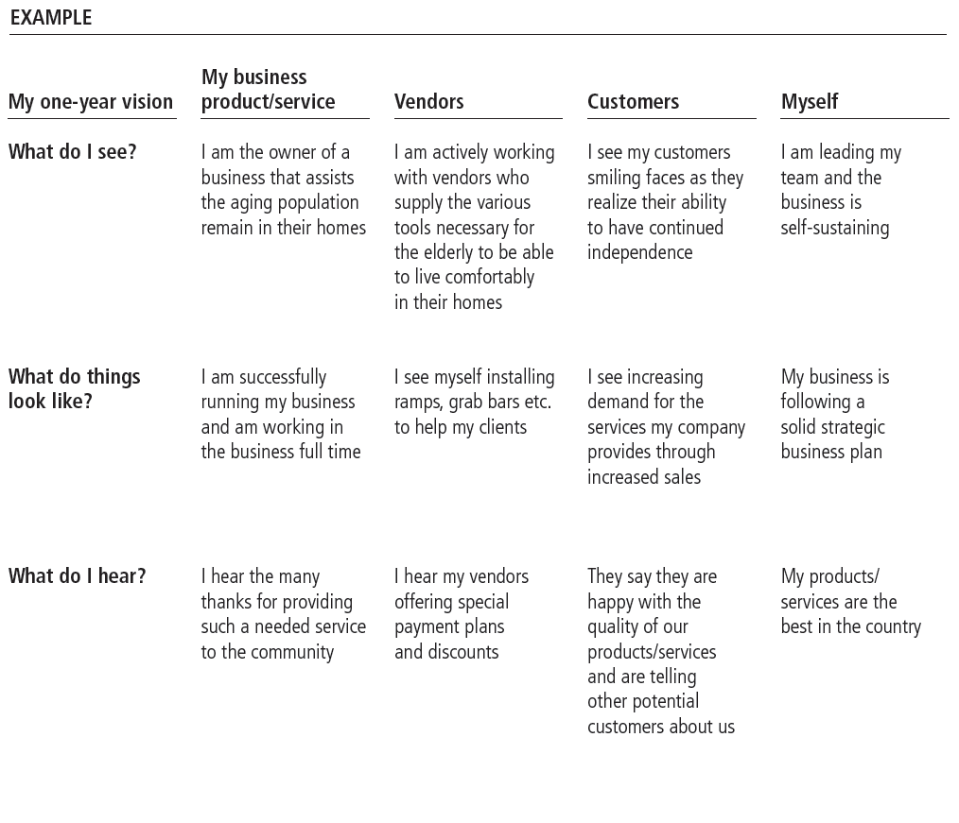

Imagine that it is one year from today and you are walking in the door of your business.
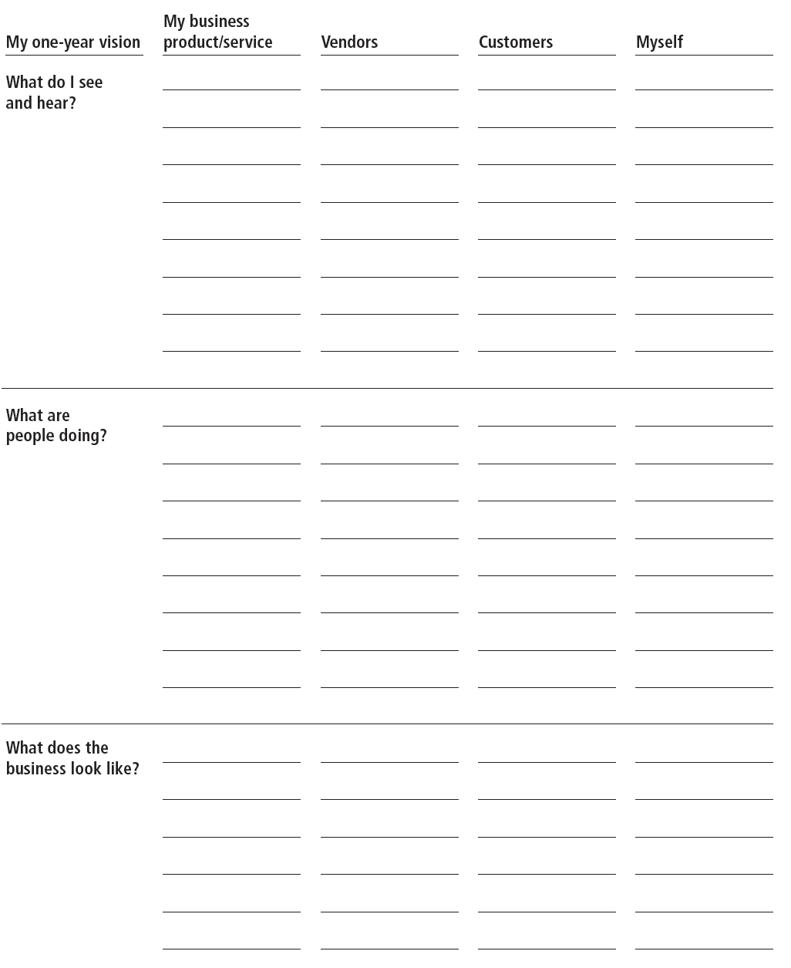

TOOL 10 - Actions, Insights, and Resources

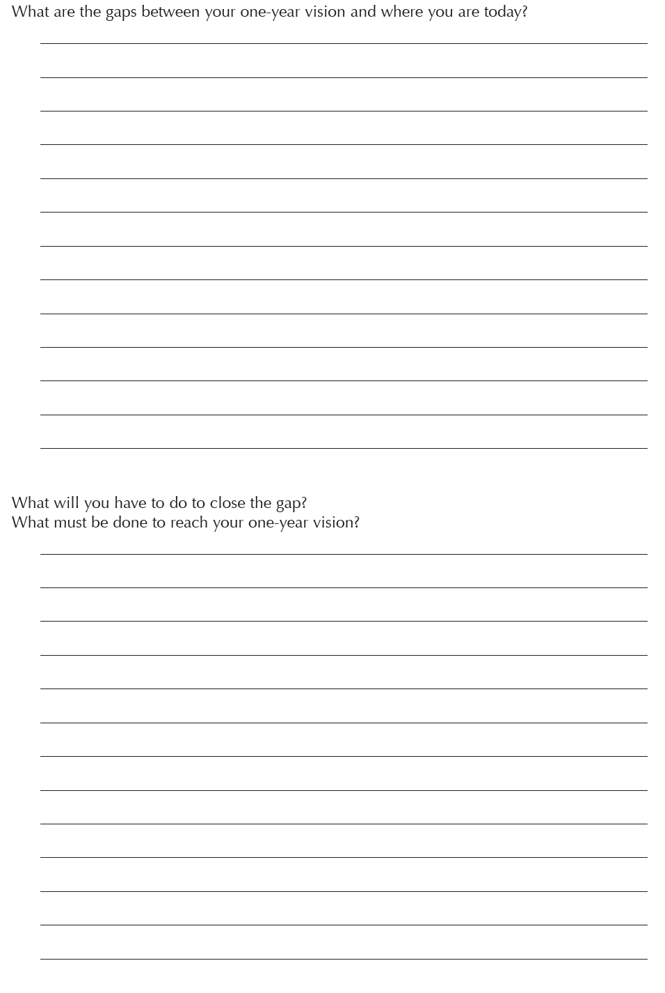
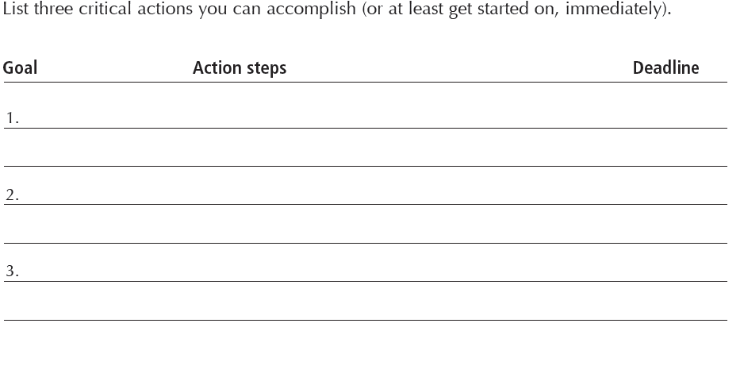

SBDC INFORMATION

KAUFMAN FOUNDATION ACKNOWLEDGEMENT
About Kauffman FastTrac®
Kauffman FastTrac, a not-for-profit educational organization, is a global provider of learning curricula that equip aspiring and existing entrepreneurs with the business skills and insights, tools, resources, and networks to start and grow successful businesses.

Kauffman FastTrac was created by the Ewing Marion Kauffman Foundation, the largest foundation in the world devoted to entrepreneurship. For more information about Kauffman FastTrac, visit fasttrac.org or follow us on Twitter @fasttrac.

© 2013 by the Ewing Marion Kauffman Foundation. All Rights Reserved.
First Edition: March 2013
ISBN: 978-0-9856783-3-3

This work has been created by the Ewing Marion Kauffman Foundation (the “Foundation”), which also owns the underlying intellectual property rights in and to the work, including the initial copyrights.

The Foundation has elected to license this work under the Creative Commons Attribution- Non Commercial- No Derivatives 4.0 International license. To view a copy of terms for this license, visit https://creativecommons.org/licenses/by-nc-nd/4.0/legalcode.

You may review a summary that explains (but does not substitute or in any way modify) the license terms here: https://creativecommons.org/licenses/by-nc-nd/4.0/.
You may link to the original version of the document licensed here: www.fasttrac.org/green.

This publication is designed to provide accurate and authoritative information in regard to the subject matter covered. It is licensed with the understanding that the publisher and authors are not engaged in rendering legal, accounting, or other professional services. If legal advice or other expert assistance is required, the services of a competent professional should be sought.

GOALS
PRIORITIES
VISION
GOALS
PRIORITIES
VISION

GOALS
PRIORITIES
VISION

