Listening to Your Business
Part I of II
Worksheets

Listening to Your Business
Participant Guide-Part 1 of 2 WORKSHEETS

Table of Contents
Welcome to Listening to Your Business

Step 1 Three-Year Vision
•Assessment Tool 1: My three-year vision
Assessment Tool 2: Where is my business today?
Assessment Tool 3: Vision gaps

Step 2 Business Life Cycle and Transitions
Assessment Tool 4: Where does my business fit in the business life cycle?
Assessment Tool 5: Business life cycle challenges and transitions

LISTENING TO YOUR BUSINESS

You want to be here in three years
Step 4 Transition Tactics
o Establish action steps for the
transition.
o Identify immediate actions needed.
Step 3 Planning Tools and Competencies
o Evaluate current planning tools.
o Identify the way plans will be
used for analysis, communication,
strategic direction, and control.
Step 1 Three-Year Vision
o Envision where you want your
business to be in three years.
o Discover where your business
is today.
o Determine necessary transitions
to reach your vision.
Step 2 Business Life Cycle and Transitions
o Verify the stage of growth of your
business.
o Decide at what stage of growth
you want your business to be in
three years.
o Ascertain the challenges of
transitioning from one stage to
another.
You are here.

ASSESSMENT TOOL 1 (CONTINUED)
MY THREE-YEAR VISION

Imagine that it is three years from today you are walking in the door of your business. What do you see and hear? What are people doing? What does the business look like?
Write down your vision for each stakeholder. After capturing your vision, turn to the next two pages and complete the questions to identify additional details to consider as you design the future.

My three-year vision | My staff | Management team | Vendors | Customers | Myself
What do I see?
What do things look like?
What do I hear?

ASSESSMENT TOOL 1 (CONTINUED)
IMAGINE IT IS THREE YEARS FROM TODAY AND YOU ARE WALKING IN THE DOOR OF YOUR BUSINESS.
(Use these additional criteria to add detail to your vision. You can add the criteria most important to your business.)

Location | Where will my business be located?
Facilities | What kind of facilities will the business occupy?
 | How many square feet?
 | Will the business own the building or lease space?
Equipment | What kind of equipment will be needed?
Computer technology | What kind of computer technology will the business have?
Products | What will the product line encompass?
Services | What services will be offered?
Market | Who makes up the customer base?
 | Will markets be local, regional, national, global?
 | What percentage of the market will the business have?
 | Will we have an online presence to include website, e-commerce and digital marketing?

Financial | What will the total sales be?
 | How much will the net profit be?
 | How much growth capital will be needed?
Where will you source your funding?
self?
borrow?
grants?
 | What types of investors will be used?
Personnel | How much support will the business have:  full-time?  part-time?  contract?
Work load | How many hours/days per week will you be working?
Growth | Will the rate of growth be:  fast?  moderate?  static?  decline?
Risks | What potential business risks might be encountered?
Exit strategy | What is the proposed exit strategy for you, the entrepreneur?

ASSESSMENT TOOL 2
WHERE IS MY BUSINESS TODAY?

You walk in the door of your business today. What do you see and hear? What are people doing? What
does the business look like?

My business today | My staff | Management team | Vendors | Customers | Myself
What do I see?
What do things look like?
What do I hear?

ASSESSMENT TOOL 3
VISION GAPS

A. List the gaps between your three-year vision and where your business is today.
1
2
3
4

B. What changes will you have to make in the way you operate your business today to reach your three-year vision?
1
2
3
4

Step 2 - Business Life Cycle and Transitions
ASSESSMENT TOOL 4
WHERE DOES MY BUSINESS FIT IN THE BUSINESS LIFE CYCLE?

Using the summary sheets for the business growth stages, pages 15-16 Participant Guidebook, check the characteristics listed for each stage of business that best fit you and your business.
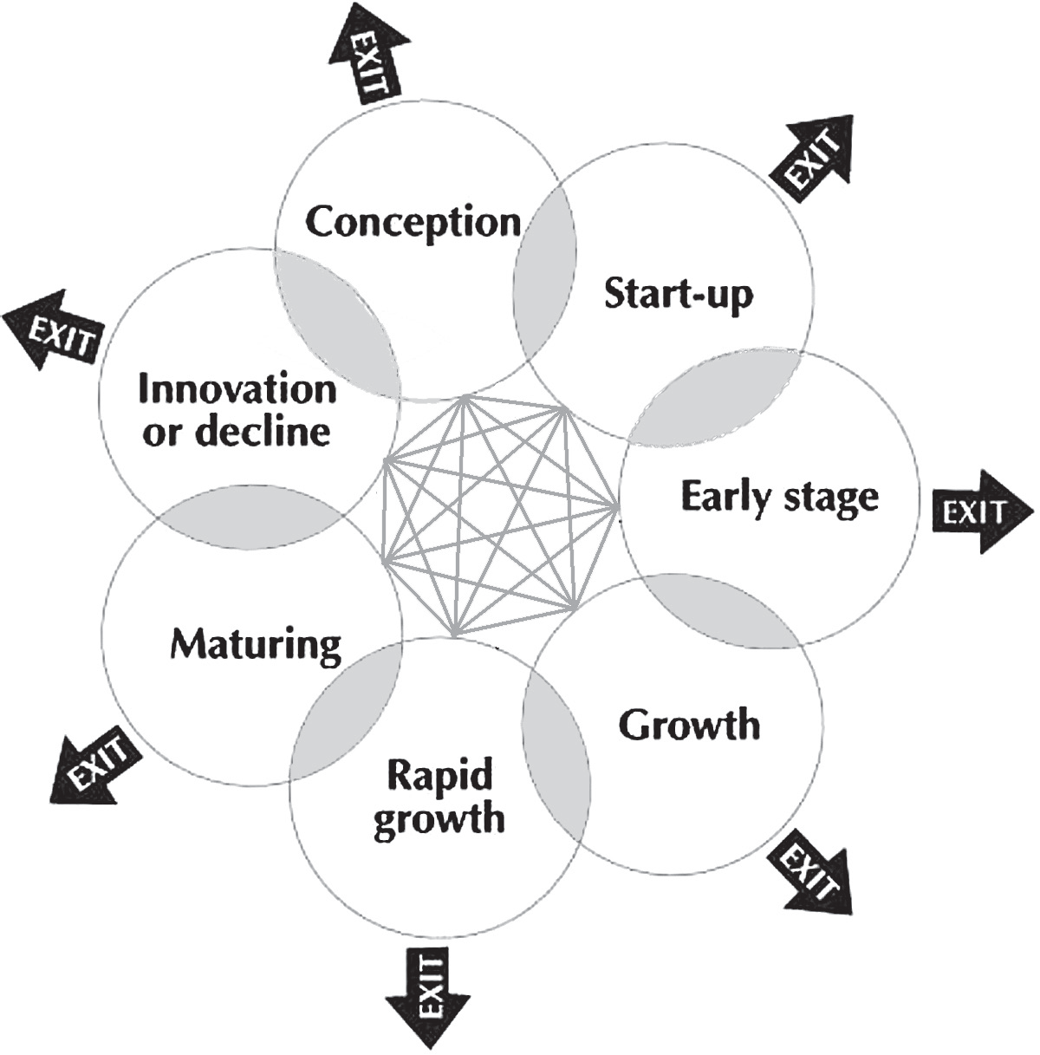
Conception Stage 15
Start-Up Stage 15
Early Stage 15
Growth Stage 15
Rapid-Growth Stage 16
Maturing Stage 16
Innovation or Decline Stage 16

ALTERNATIVE ASSESSMENT TOOL 4
Another way to determine where your business fits in the business life cycle is to chart the alignment of your business.

Use the Alternative Assessment Tool 4 that begins on page 18 (PGB) to check the alignment of your business

CONCEPTION STAGE OF BUSINESS
BUSINESS NOT FORMED YET

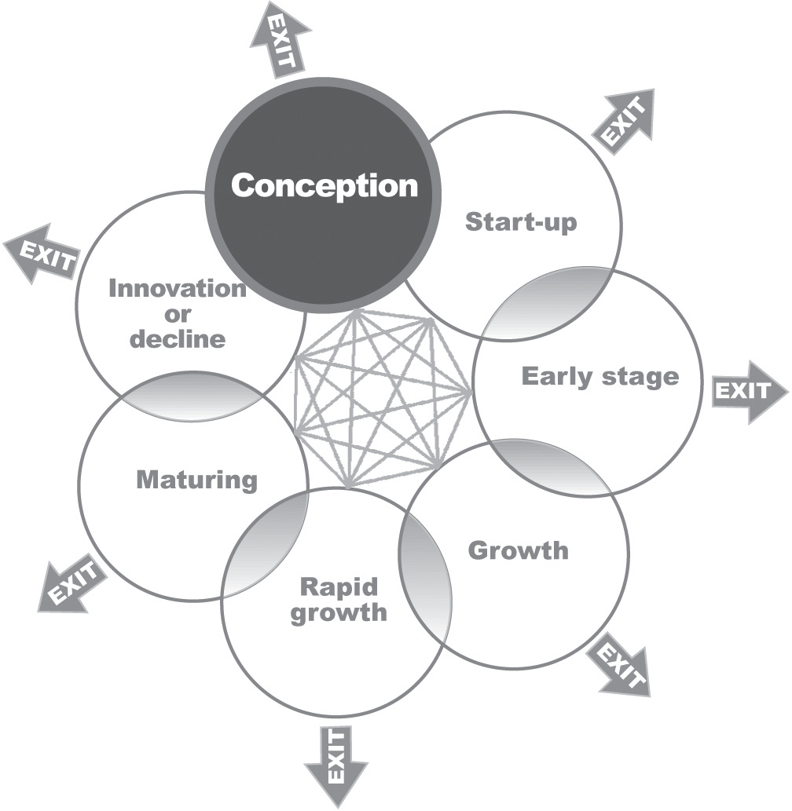
Business characteristics
- Business environment is chaotic
- Sales and growth are inconsistent at best
- Business is relatively small with few staff members
- Business continually adapts to changes
- Resources are scarce and used judiciously
Goals and objectives
- Cash break-even is reached quickly
- Target market needs are identified
- Start-up capital is available
- Products/services are sold
- Talented management team is recruited
- Start-up expenses are minimized
Entrepreneurial characteristics
- Planning and goal-setting skills
- Market focused
- Effective communicator
- Successful negotiator
Entrepreneur’s management style
- Centralizes management decisions
- Fights daily fires
- Develops aggressive market strategy devoted to launch and survival
- Delegates very few tasks
Planning characteristics
- Plan for an effective entrepreneurial team is established
- Management decisions guided by the business plan
- Business plan used as an assessment tool to measure progress against projections
- Business plan changes frequently
Red flags
- Growth is slow
- Sales do not meet projections and occur haphazardly
- No consistent sales pattern to guide planning decisions
- Products/services targeted to narrow market niches
- Competitive advantage hard to identify
- Cash flow is tight
- There is no formal planning process

START-UP STAGE OF BUSINESS
BUSINESS IS NEWLY OPENED FOR BUSINESS
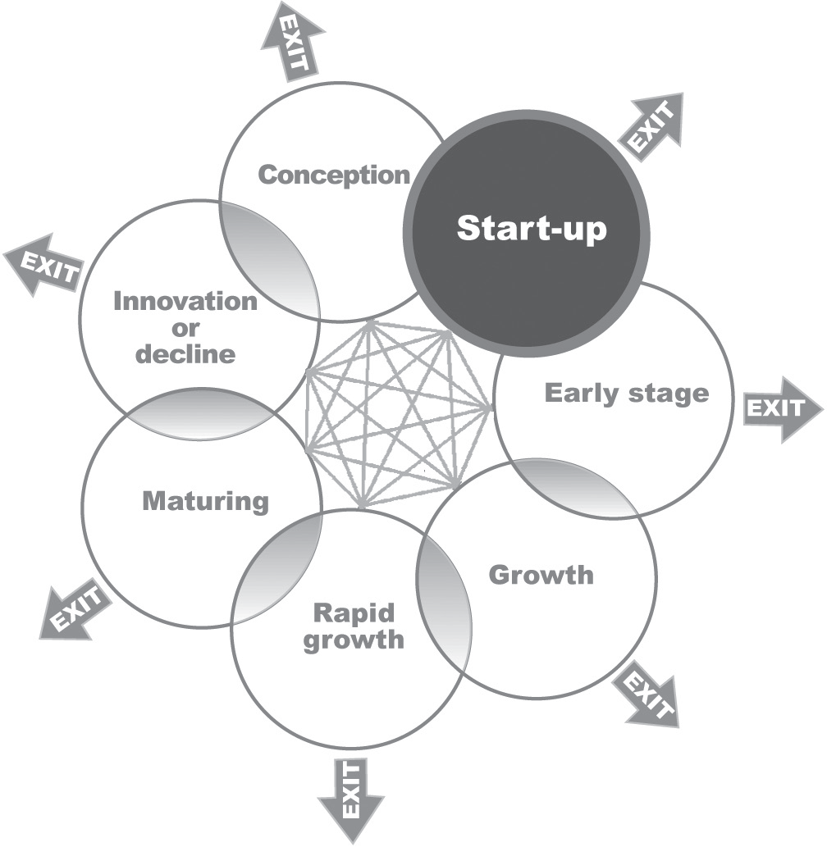
Business characteristics
- Business is fast-paced
- Entrepreneur experiments with different marketing tactics
- Customers are contacted regularly
- Business activities are sales driven
Goals and objectives
- Targeted customers are attracted
- Products/services are refined to meet market needs
- Market share is growing
- Sales volumes are increased
- Profit is achieved
- Board of advisers is established
Entrepreneurial characteristics
- Marketing oriented
- Effective communicator of business vision
- Problem solver
- Tenacious
- Delegator
- Effective motivator
- Feedback solicitor
Entrepreneur’s management style
- Builds solid management team
- Delegates responsibilities
- Addresses training needs
- Manages resources creatively
Planning characteristics
- Cash flow activity is tracked
- Staff policies and responsibilities are outlined
- Business progress is charted and compared with the business plan
Red flags
- Daily tasks overwhelm management
- Little time to spend with staff who need direction
- Entrepreneur micro manages
- New competition emerges
- Priorities continually change
- Business loses focus
- Entrepreneur spends too much time working in the business rather than on the business
- Numerous marketing challenges are encountered

EARLY STAGE OF BUSINESS
ACQUIRED CUSTOMERS BUT NEED TO EXPAND SALES

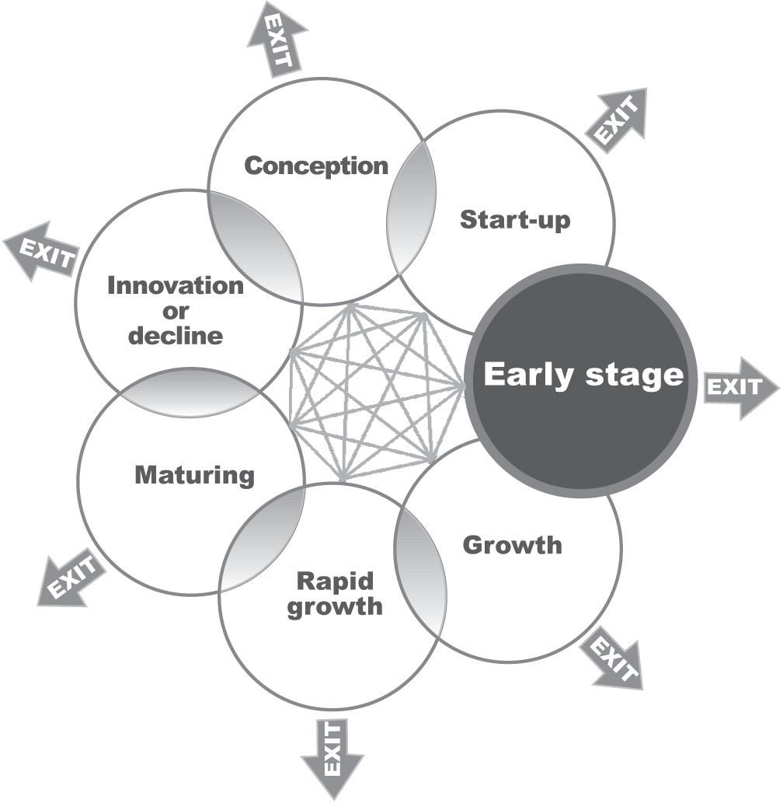
Business characteristics
- Business is established as a viable business
- Market niches are well defined
- Planning and control systems are operating
- Entrepreneur is bombarded by both growth enablers
and growth inhibitors
- Business is cash poor and needs money to expand
Goals and objectives
- Aggressive growth strategies are pursued
- Growth financing is sought
- Business becomes a market leader and expands market share
- Talented staff members are attracted
- Board members are very involved
- Business value is increased
Entrepreneurial characteristics
- Effective communicator of business vision
- Strategic planner, goal setter
- Effective manager, facilitator, mentor, team builder
- Gives feedback
- Problem solver
Entrepreneur’s management style
- Develops effective management team
- Steps back from the daily operations and manages business with the overall plan in mind
- Makes major changes in entrepreneurial strategies
- Aligns management team with business vision and culture
- Coaches others
- Encourages ideas and discusses alternatives
Planning characteristics
- Strategic and operating plans are used to formulate strategies and integrate benchmarks
- Plans include how the business will grow, manage sales, and remain profitable
- All resources are used to finance growth
- Focus on business side of operations
- Design exit strategy
Red flags
- Lack of sufficient assets to use as collateral for expansion capital
- Rapid growth uncontrollable
- Shortage of management expertise and intellectual capital
- Insufficient cash flow to support growth
- Entrepreneur unable to cope with management and growth challenges
- Staff members become disenfranchised

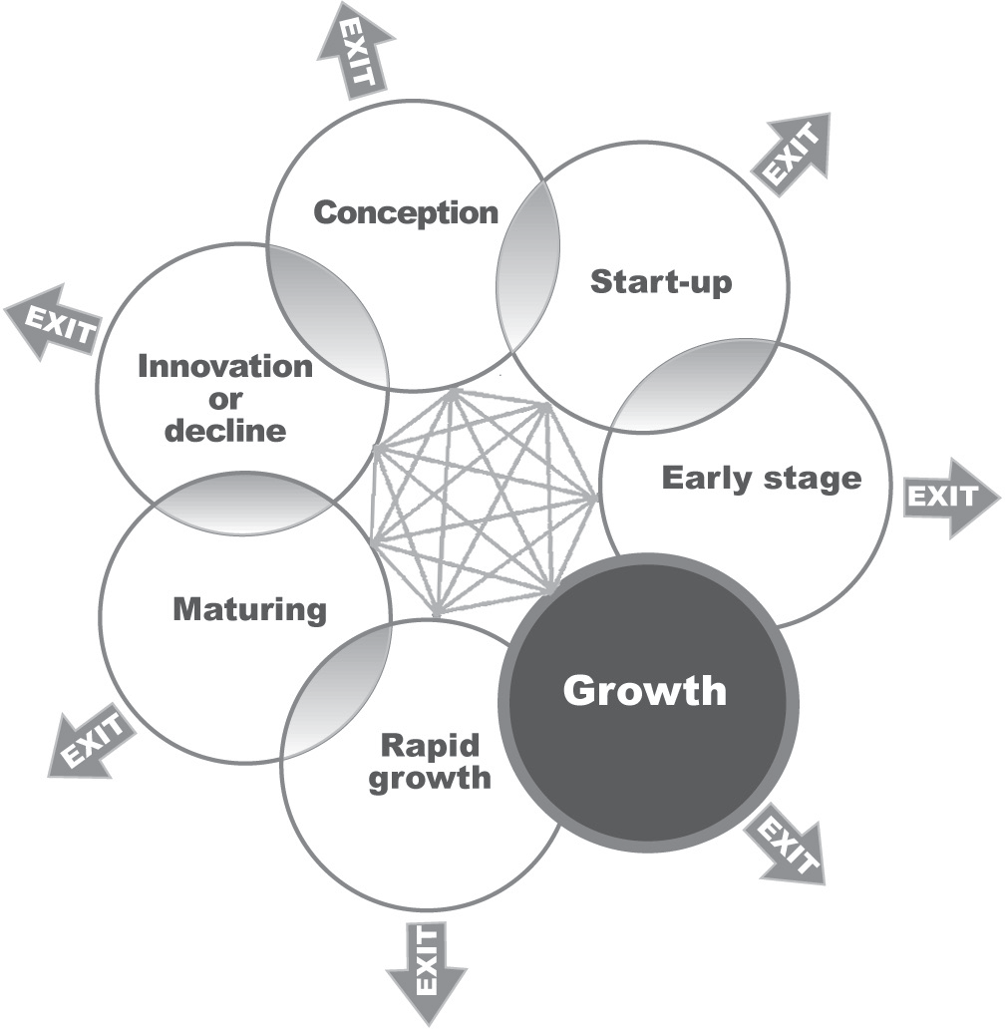
GROWTH STAGE OF BUSINESS
GROWING AT LEAST AT SAME PACE AS INDUSTRY

Business characteristics
- New opportunities are sought
- Customers and staff members are added quickly
- Business is a market leader
- Business is able to sustain its competitive edge
- Operations are structured
Goals and objectives
- Markets are expanded
- Brand awareness is created
- Financing for growth is found
- Board provides scheduled, regular input
- Global opportunities are explored
- Business takes advantage of technology
Entrepreneurial characteristics
- Effective communicator of business vision
- Strategic planner, goal setter
- Tracks financial performance and successfully acquires necessary funds
- Effective motivator and team leader
- Problem solver
- Successful negotiator
- Develops strategic alliances
Entrepreneur’s management style
- Standardizes and streamlines operations
- Focuses on developing management team
- Resolves disagreements and seeks collaboration
- Focuses on the vision
Planning characteristics
- Operating plan is carefully reviewed and tracked
- Staff is involved in annual review and revision of strategic plan
- Cash flow is carefully monitored
Red flags
- Expanded too quickly
- Lacks clear vision
- Poor directions, unwieldy
- Competitive threats
- Too many priorities
- Frequent staff/management conflicts
- Product/service shortages and delays
- Outgrowing current management team expertise

RAPID-GROWTH STAGE OF BUSINESS
OUTPACING INDUSTRY

Business characteristics
- Business is an industry leader with well-established markets
- Sales patterns are stabilized
- Business remains somewhat stable as long as it continues
to respond to market needs
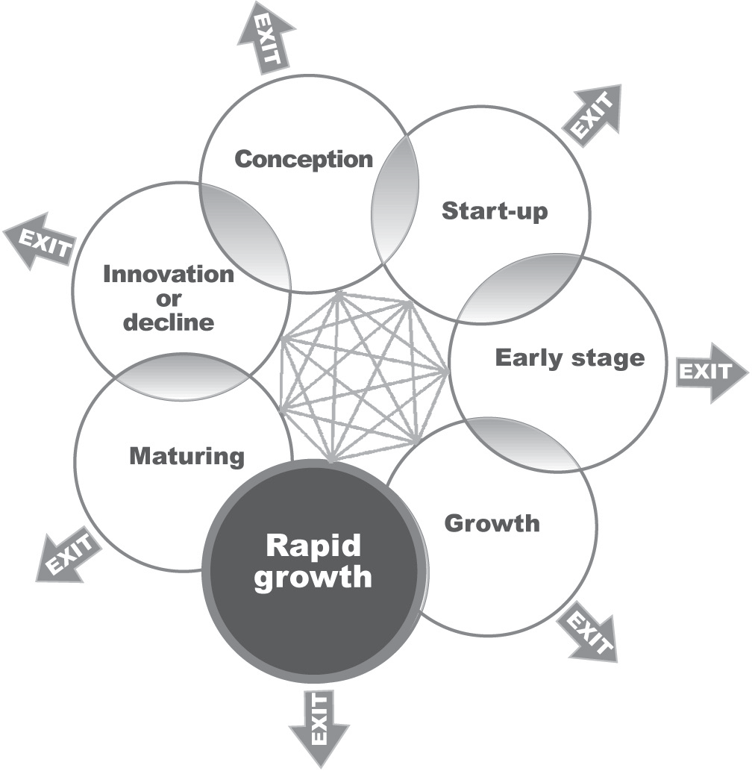
Goals and objectives
- Business is reinvented
- Be competitive and remain flexible
- Innovative products/services are created
- Brand awareness is maintained
- Business expands globally or acquires new companies
- Wealth is created
Entrepreneurial characteristics
- Effective communicator of business vision
- Strategic planner, goal setter
- Effective motivator and team leader
- Change agent
- Problem solver
- Forecasts future
Entrepreneur’s management style
- Creates innovation at all levels of the organization
- Proactively manages for future
- Preserves and creates value
- Balances short- and long-term growth
- Molds management team
- Divides departments into separate business units
Planning characteristics
- Operating plan is carefully reviewed and tracked
- Progress and profitability is measured and monitored
- Growth strategies are developed
- Business transformation is planned
- Strategic plan is revised
Red flags
- Business in turmoil, staff lacks shared values
- Market saturation with excessive competition
- High staff turnover
- Decreasing profits

MATURING STAGE OF BUSINESS
STABILIZED MARKET SHARE

Business characteristics
- Business is an industry benchmark but it must innovate or exit
- Innovation is required at all levels of the organization
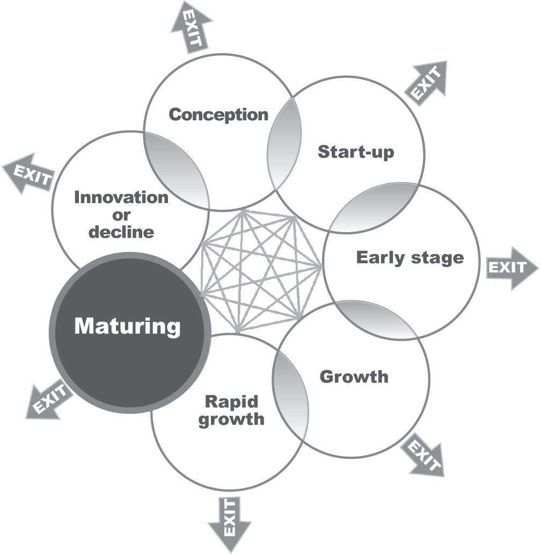
- New products/services are the responsibility of all staff members
- Focus is on high standards
- Customers and advisers input is solicited
- Current offerings are reinvented
Goals and objectives
- Innovation occurs internally or by acquisition
- New niches in the current market are established
- New or spin-off products/services are introduced
- Product/service lines are expanded
- New internal businesses are created and backed by
existing financial resources
Entrepreneurial characteristics
- Creative, innovative, persistent, and consistent
- Effectively reinforces vision
- Strategic planner, goal setter
- Calculated risk taker
- Problem solver
- Effective motivator and team leader
Entrepreneur’s management style
- Articulates the business vision
- Instills creative culture
- Balances innovation and flexibility
- Solicits continual staff member input
Planning characteristics
- Strategic plan is adjusted for market shifts
- Team members are hired, developed, managed, and recognized
- Priorities are managed with a team approach
- Operating plan is used to set milestones, reinforce mission and vision
- Progress is measured
Red flags
- Innovation is a tough challenge
- Bureaucratic management style slows decision-making
- Staff members lose touch with external conditions
- Lack of out-of-the-box thinking
- Restrictive policies and procedures

INNOVATION OR DECLINE STAGE OF BUSINESS
MUST ADD TO PRODUCT LINE OR MARKET SHARE DECLINES

Business characteristics
- Business is an industry benchmark but it must innovate or exit
- Innovation is required at all levels of the organization
- New products/services are the responsibility of all staff members
- Focus is on high standards
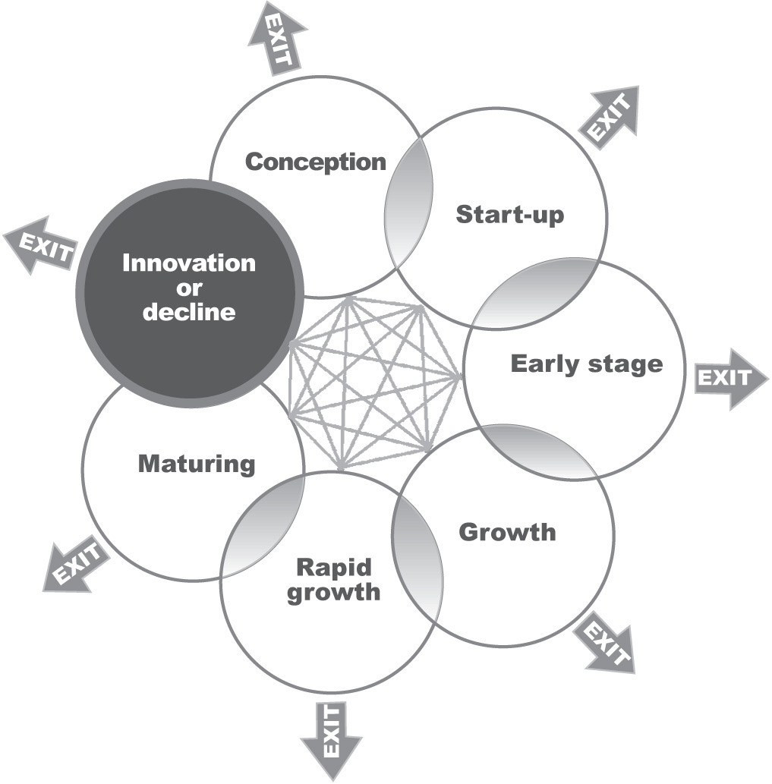
- Customers and advisers input is solicited
- Current offerings are reinvented
Goals and objectives
- Innovation occurs internally or by acquisition
- New niches in the current market are established
- New or spin-off products/services are introduced
- Product/service lines are expanded
- New internal businesses are created and backed by
existing financial resources
Entrepreneurial characteristics
- Creative, innovative, persistent, and consistent
- Effectively reinforces vision
- Strategic planner, goal setter
- Calculated risk taker
- Problem solver
- Effective motivator and team leader
Entrepreneur’s management style
- Articulates the business vision
- Instills creative culture
- Balances innovation and flexibility
- Solicits continual staff member input
Planning characteristics
- Strategic plan is adjusted for market shifts
- Team members are hired, developed, managed, and recognized
- Priorities are managed with a team approach
- Operating plan is used to set milestones, reinforce mission and vision
- Progress is measured
Red flags
- Innovation is a tough challenge
- Bureaucratic management style slows decision-making
- Staff members lose touch with external conditions
- Lack of out-of-the-box thinking
- Restrictive policies and procedures

ASSESSMENT TOOL 4
WHERE DOES MY BUSINESS FIT IN THE BUSINESS LIFE CYCLE?
To chart the alignment of your business, use the table on pages 26-29 (PGB). In each category, circle the box that best describes your business activities and characteristics. Then, using your pen, connect each circled box, starting with the first circle and moving down the page, to form a vertical line graph. Is the alignment of your business smooth and in sync or irregular and erratic? Is your business outgrowing your management style?
Is your staff exhausted from activities that keeps them zig-zagging?

ASSESSMENT TOOL 4: WHERE DOES MY BUSINESS FIT IN THE BUSINESS LIFE CYCLE?
Category | Conception | Start-up | Early stage | Growth | Rapid growth | Maturing | Innovation or decline
Business characteristics | Entrepreneur has found a business opportunity, but the business is not yet formed or the idea is still being tested. | Sales and growth are erratic and the business is small, chaotic and resources are scarce. | Business is sales-driven, fast-paced, experiments with marketing, and has a close relationship with its customers. | Business is viable, the market is well defined, processes and procedures are in place, and the business needs money to expand. | Market leader with competitive edge, launching new ideas and products, hiring, and the planning and operational structures are in place. | Industry leader, consistent market and sales patterns, poised to continue growth and profitability or decline from lack of innovation. | Business has flat-line growth and profitability and not sure what needs to be done but knows it must reinvent itself because it is the beginning of a decline.
Goals and objectives | Determine resources needed, complete start-up business plan, find location, identify suppliers, source capital, and hire staff. | Complete business and marketing plans, obtain capital, target market, sell products or services, build team, and control expenses. | Modify business and marketing plans, refine products and services, increase market share, establish a board, and realize a profit. | Source financing for increased growth, become market leader, hire talented people, involve board, increase value of business, update business and marketing plans, and create strategic and operational plans. | Expand markets, create brand awareness, finance growth, hold regular board meetings,  explore global opportunities, become technically savvy, continually refine business, marketing, strategic and operational plans. | Reinvent business, remain flexible, redesign products and services, maintain reputation and brand, expand or purchase market share, create wealth, write new business, marketing, and strategic plans. | Innovate internally or by acquisition, grow new niche markets, develop new products and services, create profit centers within business, and write new business plans.
Entrepreneurial characteristics | Visionary  Driven  Self-confident  Creative  Resolves problems  Intuitive | Plans.  Sets goals.  Marketing focus.  Team communicator.  Negotiates.  Oversees daily operations.  Sells.  Resolves problems. | Marketing oriented.  Visionary.  Tenacious.  Delegator.  Motivational.  Solicits feedback.  Solves problems. | Communicates vision. Planner/goal setter.  Coach.  Facilitator.  Mentor.  Mediator.  Team builder.  Gives feedback.  Solves problems. | Communicates concrete vision.  Strategic planner.  Sets goals.  Manages financials.  Team leader/motivator.  Self-confident.  Negotiates.  Develops alliances.  Solves problems. | Creative/innovator.  Persistent.  Reinforces vision.  Planner/goal setter.  Confident risk taker.  Leader of growth.  Facilitates teamwork.  Strategic leadership.  Motivational.  Develops people.  Solves problems. | Effective management team  Removed from day-today operations.  Manages in larger context  Makes major changes in strategies.  Aligns management team to vision and culture.  Coaches.  Encourages ideas  and alternatives.  Sense of urgency.  Standardized operations.

ASSESSMENT TOOL 4: WHERE DOES MY BUSINESS FIT IN THE BUSINESS LIFE CYCLE?
Category | Conception | Start-up | Early stage | Growth | Rapid growth | Maturing | Innovation or decline
Entrepreneur’s management style | Jack-of-all-trades  Makes all decisions  Focuses on day-to-day activities  Reactive management | Centralized management.  Centralized authority.  Fights daily fires.  Aggressive market strategy.  Devoted to launch and survival  Minimal delegation  Team focused | Builds solid management team.  Delegates.  Problem-solving mode.  Addresses training.  Creatively manages resources. | Effective management team  Removed from day-today operations.  Manages in larger context  Makes major changes in strategies.  Aligns management team to vision and culture.  Coaches.  Encourages ideas and alternatives. | Sense of urgency.  Standardized operations.  Focus on management team development.  Resolves disagreements.  Seeks collaboration.  Future focused. | Creates innovation at all levels of organization.  Proactive management.  Preserves/creates value.  Balances short-term and/or long-term growth.  Molds management team.  Divides departments into profit centers. | Articulates vision.  Accountability and team building.  Creative culture.  Balances innovation and flexibility.  Solicits continual team input.
Planning characteristics | Develops start-up business plan.  Uses plan to determine action.  Develops budgets.  Estimates break-even. | Develops business plan.  Plan used with the team.  Management uses plan to make decisions.  Progress measured against plan.  Frequent changes in business plan. | Tracks cash flow.  Outlines employee roles and responsibilities.  Charts progress to plan.  Needs systems and structure. | Benchmarks established from marketing, strategic and operational plans.  Plans growth, sales and  profitability.  Resources dedicated to  growth.  Priorities set through planning process.  Designs exit strategy. | Reviews and tracks operational plan.  Team involved in annual strategic planning.  Monitor cash flow. | Monitors operational plan.  Measures progress and  profitability.  Develops growth  strategies.  Plans business transitions.  Revises strategic plan. | Adjusts strategic plan.  Hires, develops, manages, and rewards team.  Instills creative culture.  Balances innovation and flexibility.  Solicits continual input into business.
Red flags | Runs business by seat of pants.  Too much to get done in available time.  Unorganized, no focus.  Poor follow through.  Lacks attention to detail.  No planning process. | Slow growth.  Sales erratic and less than projections.  Target market is too narrow.  Difficult to find competitive advantage.  Products and services  hard to modify.  No cash to pay bills.  No planning process. | Daily tasks are overwhelming.  No time to give direction  to the team.  Micro management.  New competition emerges.  Priorities continually change.  Business loses focus.  Too much time working in rather than on the business.  Numerous marketing challenges.  Entrepreneur shoots from the hip. | Lack sufficient assets to  leverage capital needs.  Rapid growth is uncontrollable.  Shortage of management  expertise and intellect.  Cash flow crisis.  Entrepreneur not able to keep pace with business demands.  Losing control of business.  Office infighting.  Disenfranchised team members. | Business expands too quickly.  No clear vision.  Poor directions.  Competitive threats.  Right hand doesn’t know what the left hand is doing.  Too many priorities.  Key management thinking of leaving.  Frequent team conflicts.  Shortages/delays in sales/service.  Outgrowing management team expertise. | Business is in turmoil.  Team lacks shared vision.  Market saturated with cheaper look-alikes.  High staff turnover.  Decreasing profits.  Team gets blindsided. | Innovation is challenging.  Increasing turf wars.  Excessive committee  decision-making.  Team losing touch with external conditions.  No communication time.  Lack out-of-the-box thinking.  Restrictive policies and procedures.

ASSESSMENT TOOL 5
BUSINESS LIFE CYCLE CHALLENGES AND TRANSITIONS

Identify your current and future business stages by answering the following questions.

What stage is your business in today?

Using input from your three-year vision, what stage you would like your business to be in three years from today?

Describe the business’s major challenges by answering the following questions.

What are the major challenges facing your business in its current stage of growth?

What are the challenges your business will face in the desired stage of growth three years from today?

What personal changes in your style and role as leader will you have to make to transition your business?

How will your management team assist you with this transition?

How do I prepare for the potential effects of sudden natural or manmade disasters?

Do I have such a plan established to deal with potential disruption?

Key Consideration

When planning for potential disruption, consider the NMSBDC’s Disaster Preparedness Response and Recovery Guide as a tool. You can access the document at: www.nmsbdc.org

Notes

